**Day 8  
Encapsulation, Enum, Nested Class, Singleton**

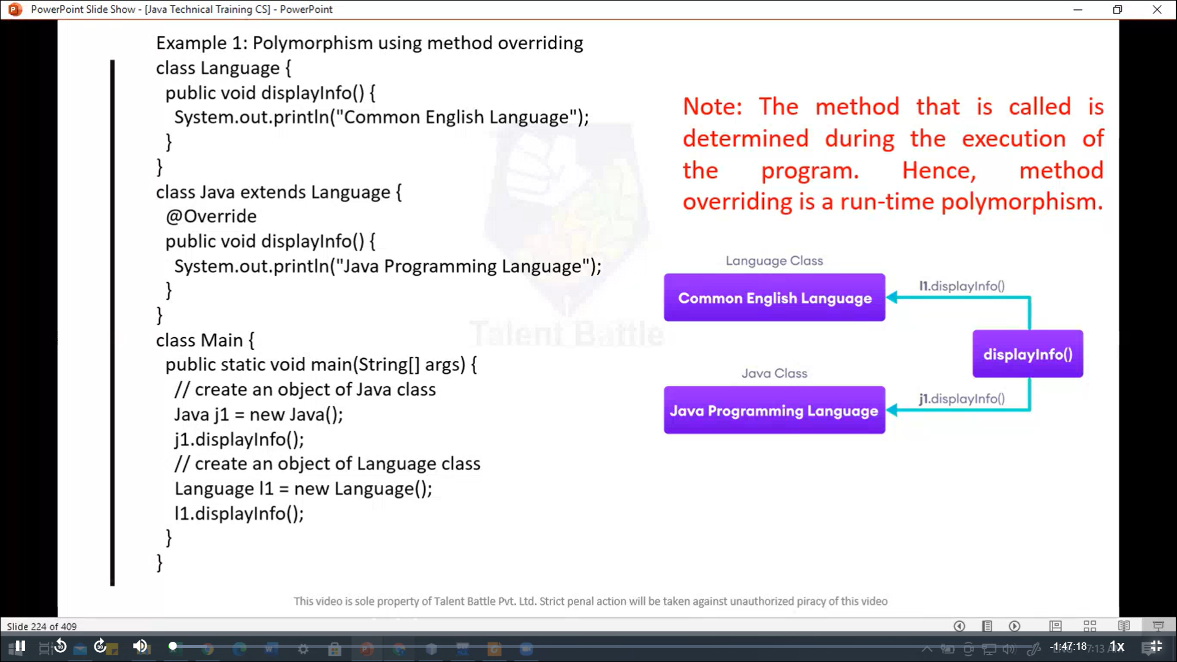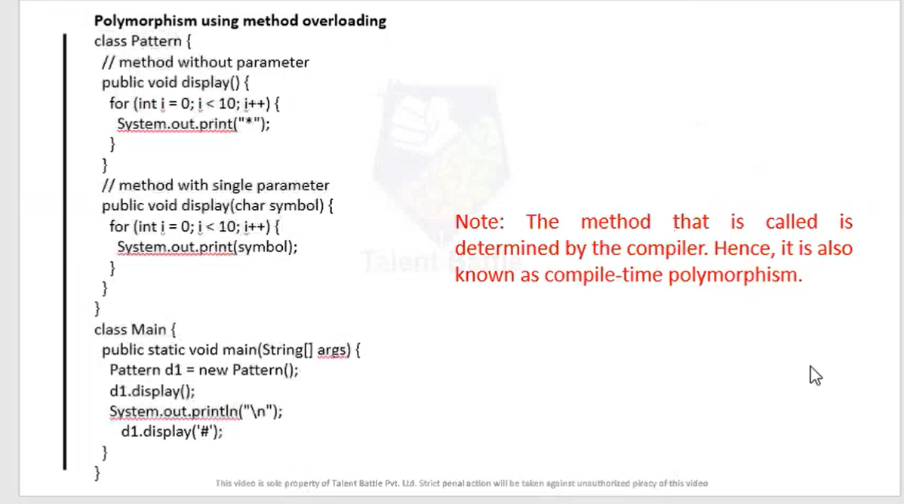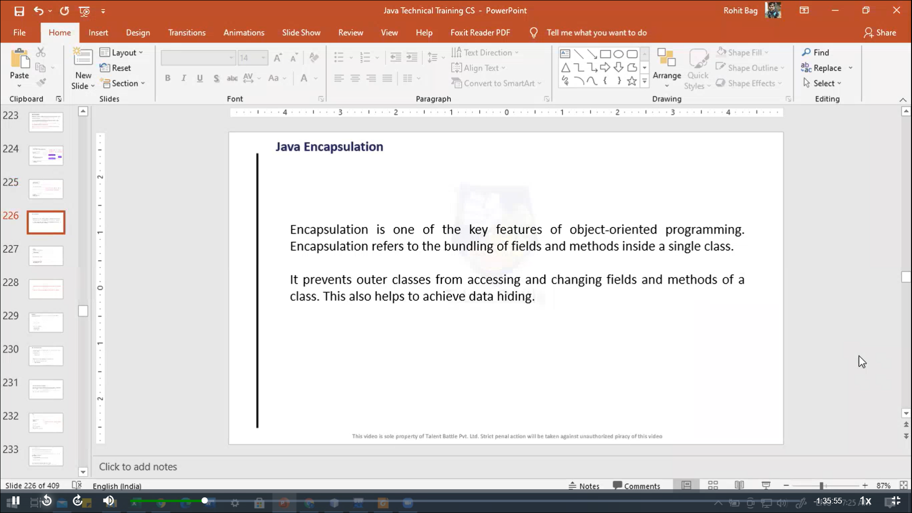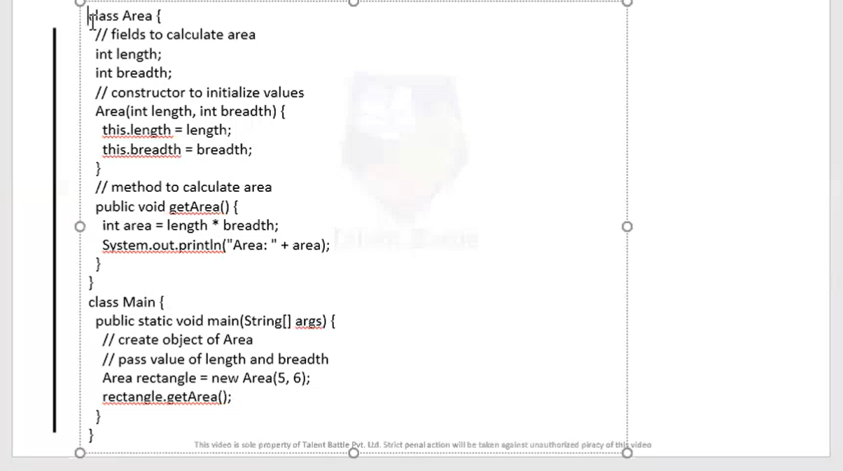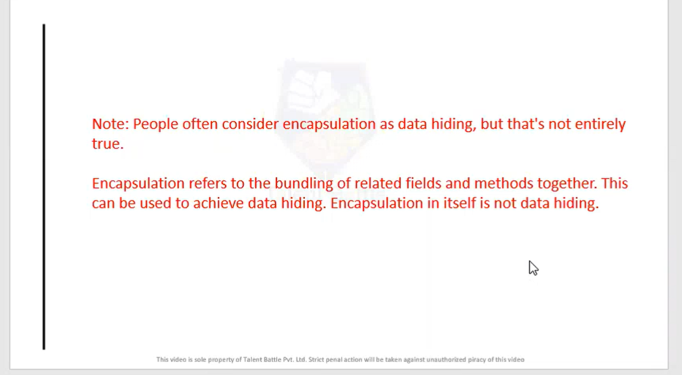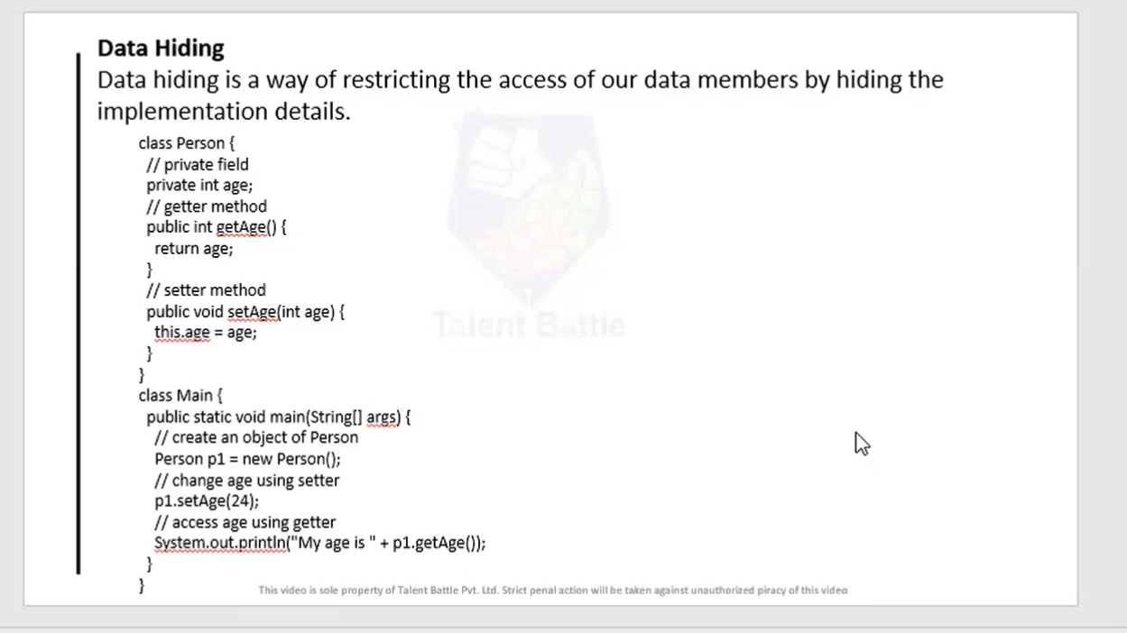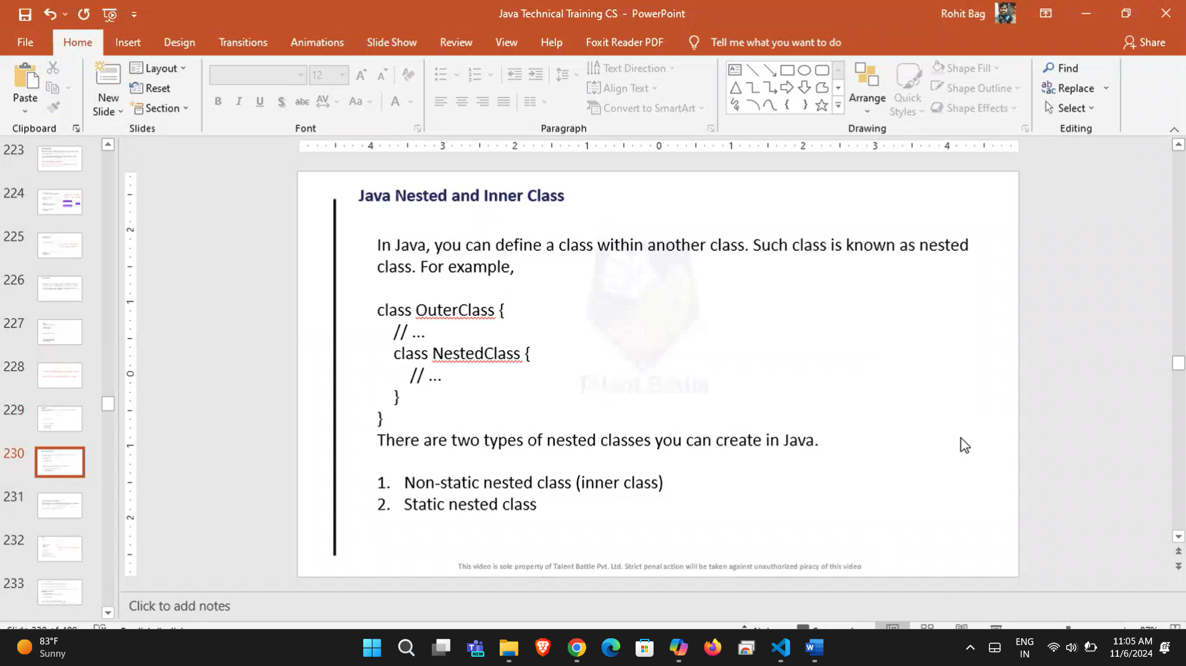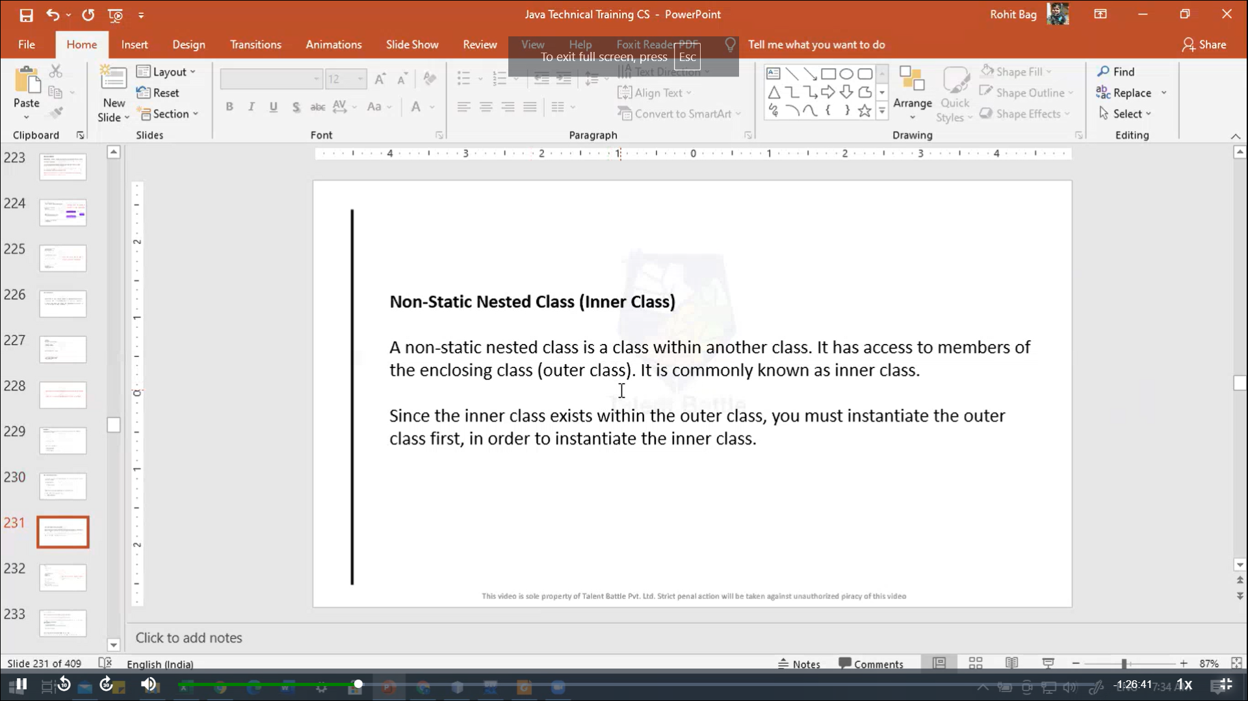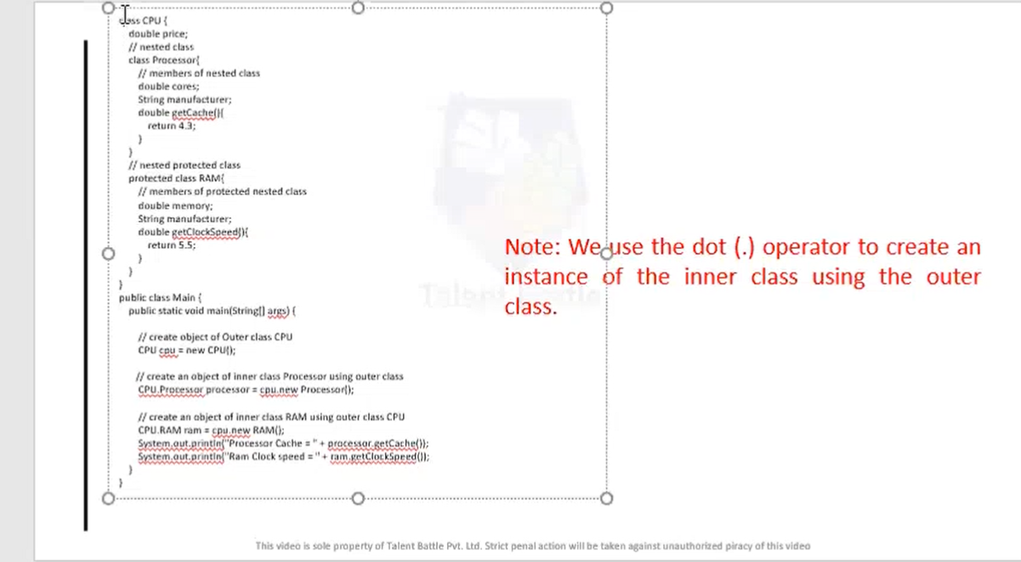

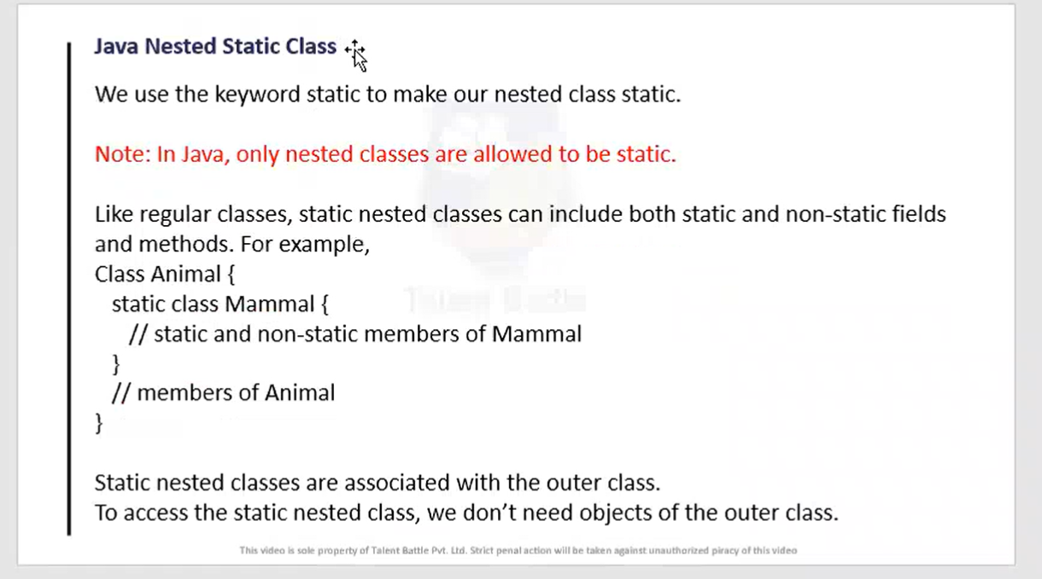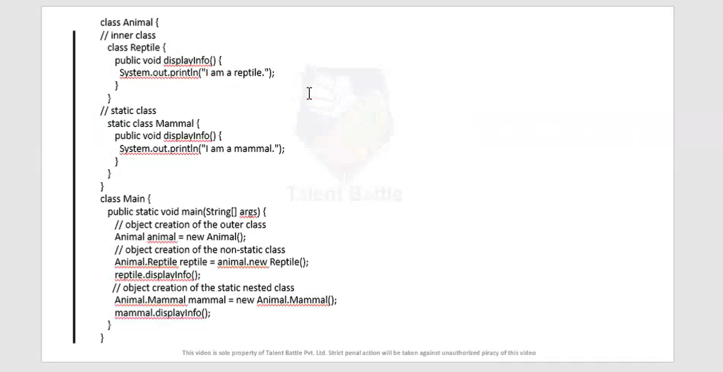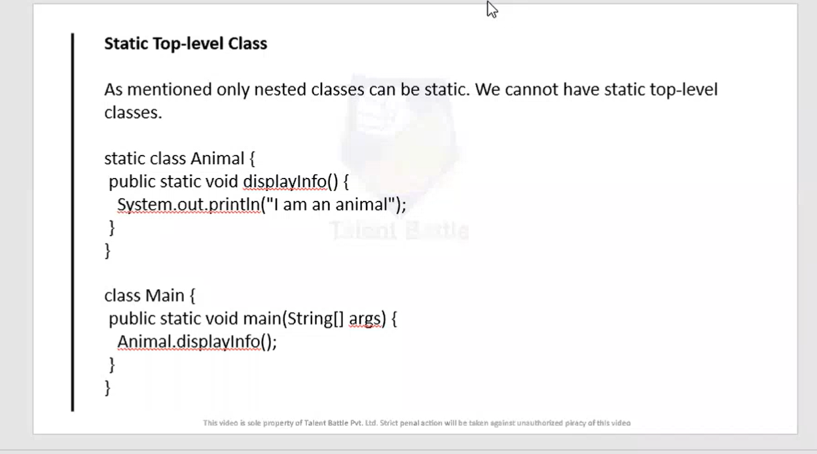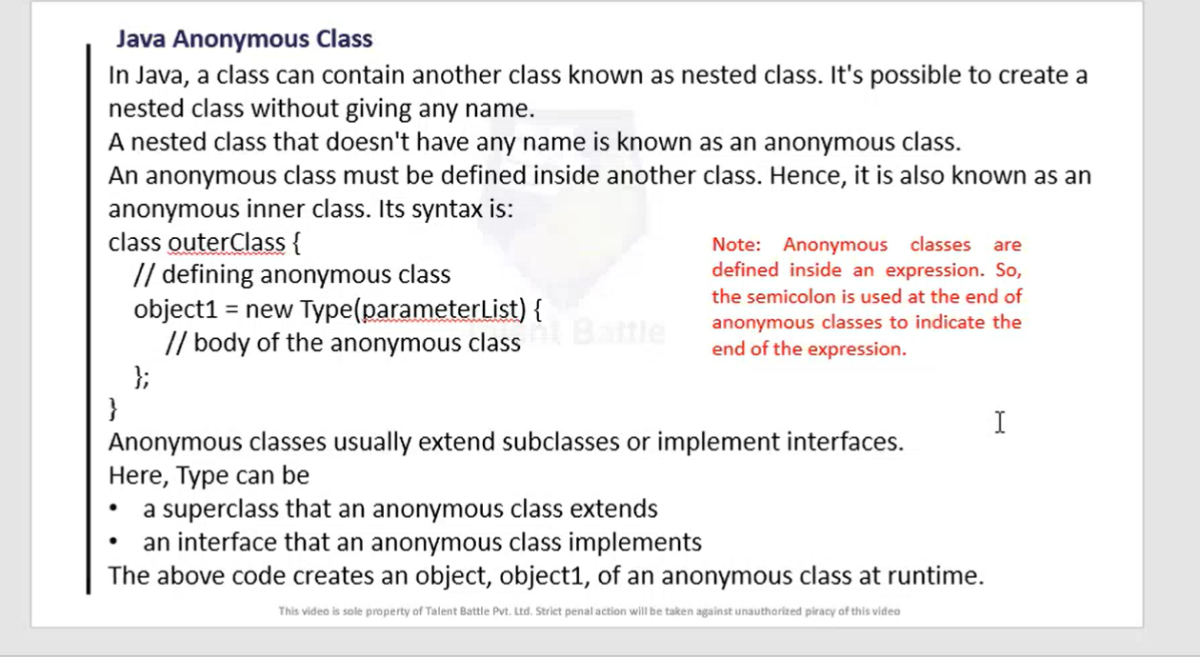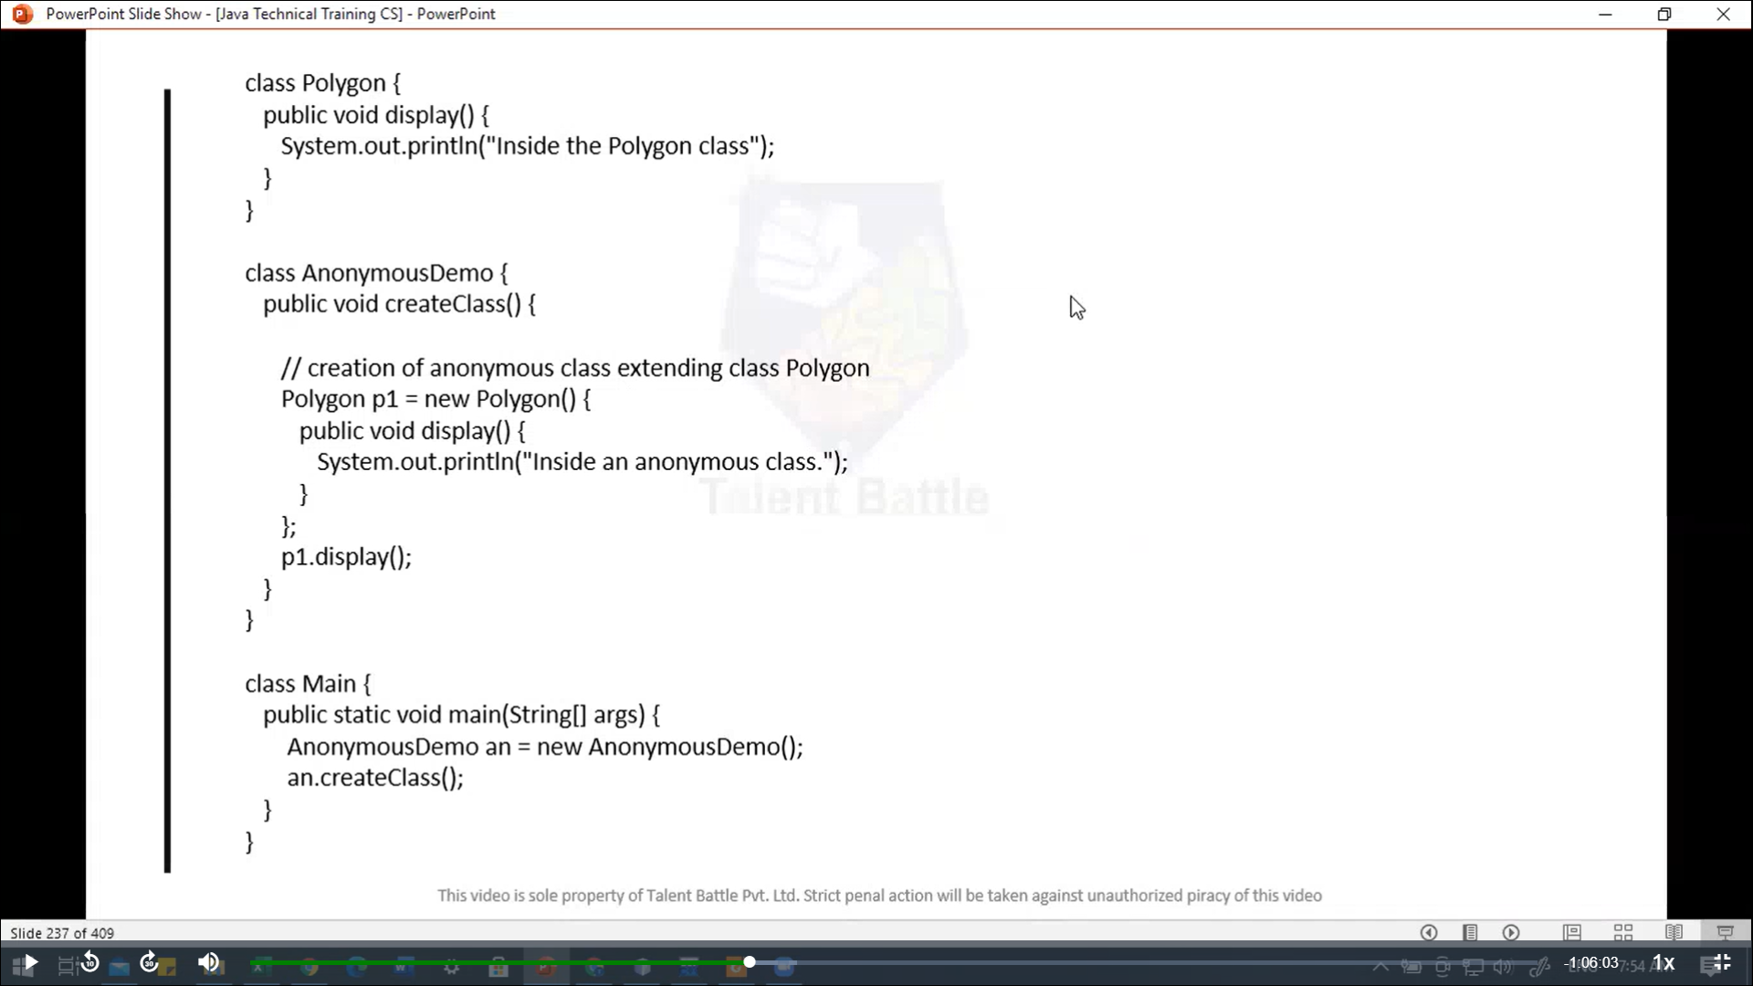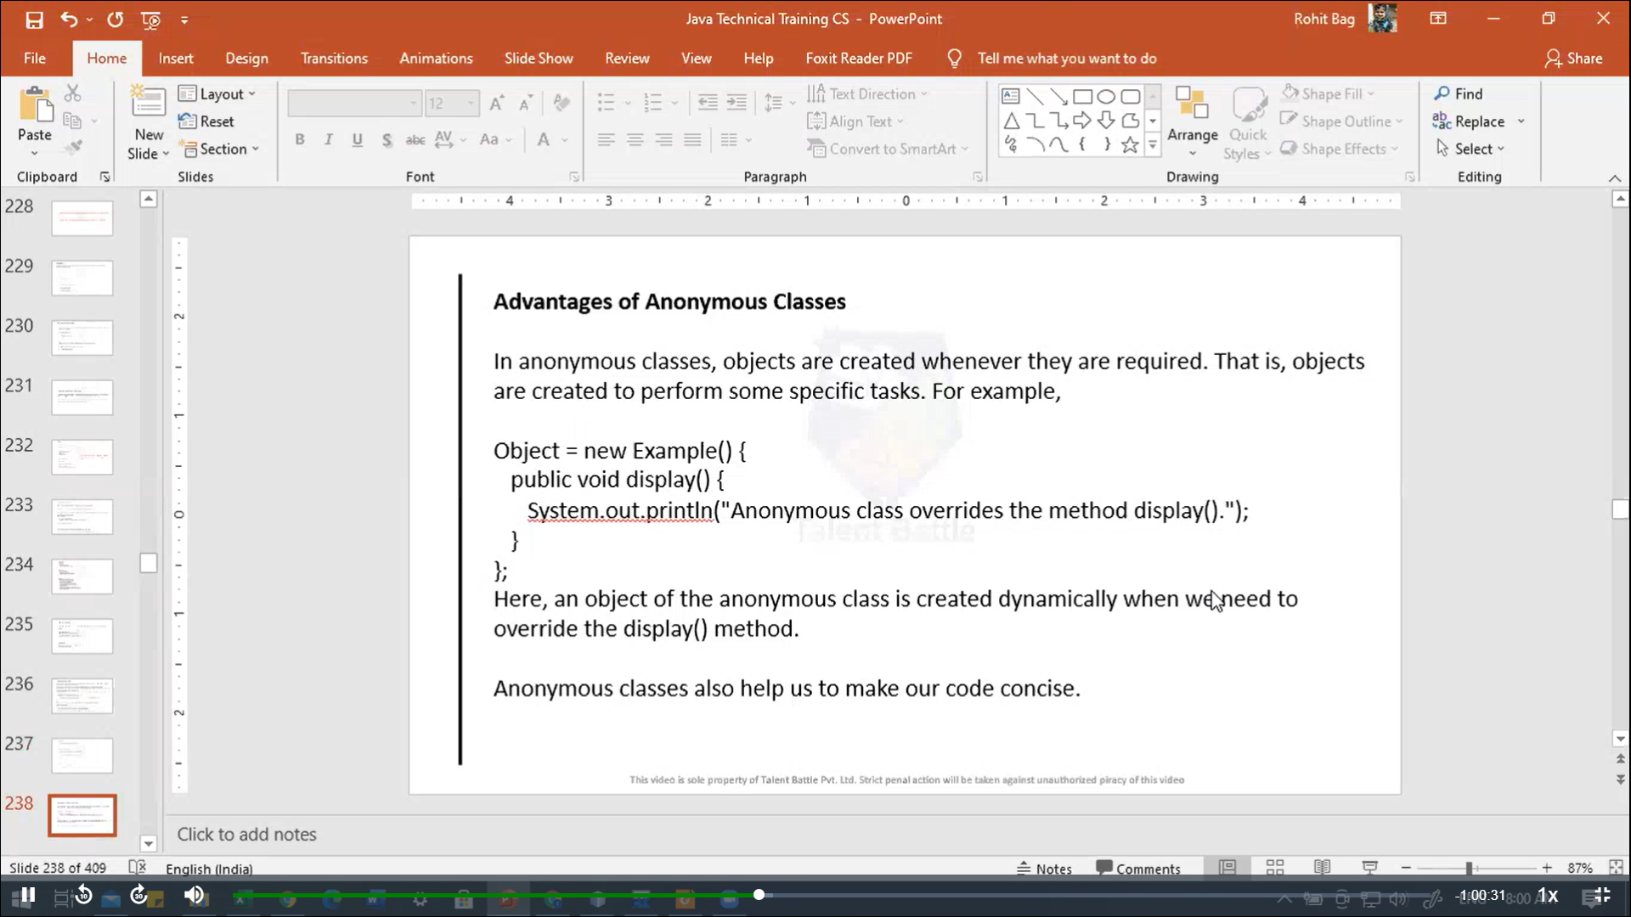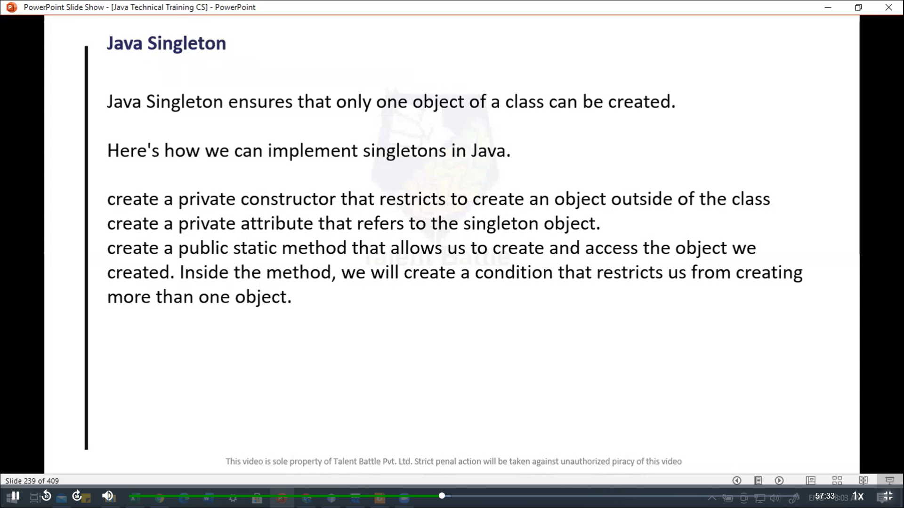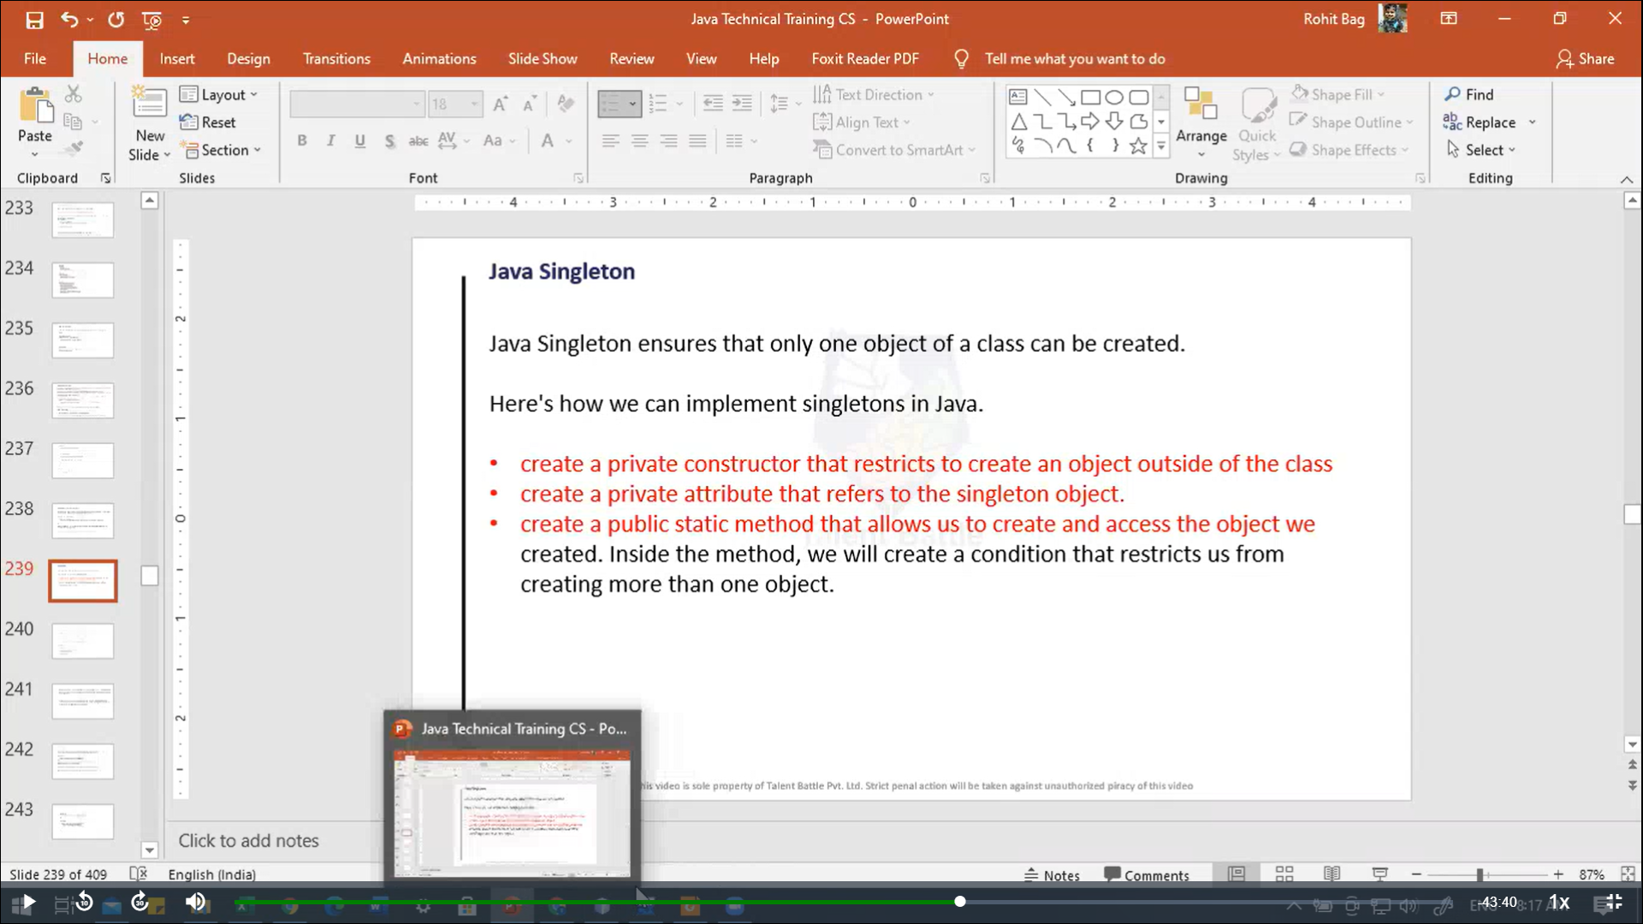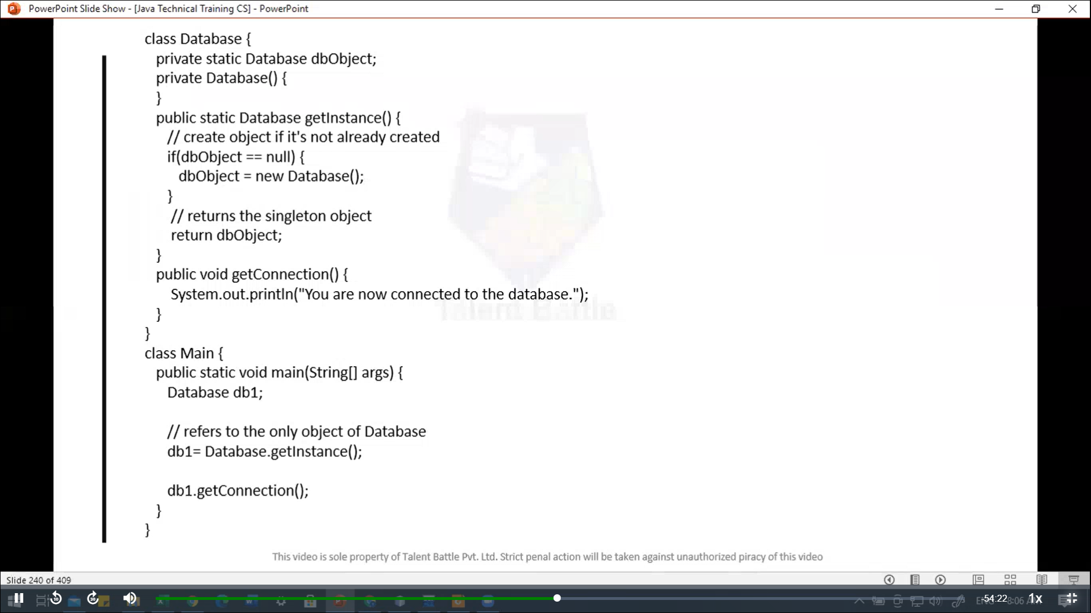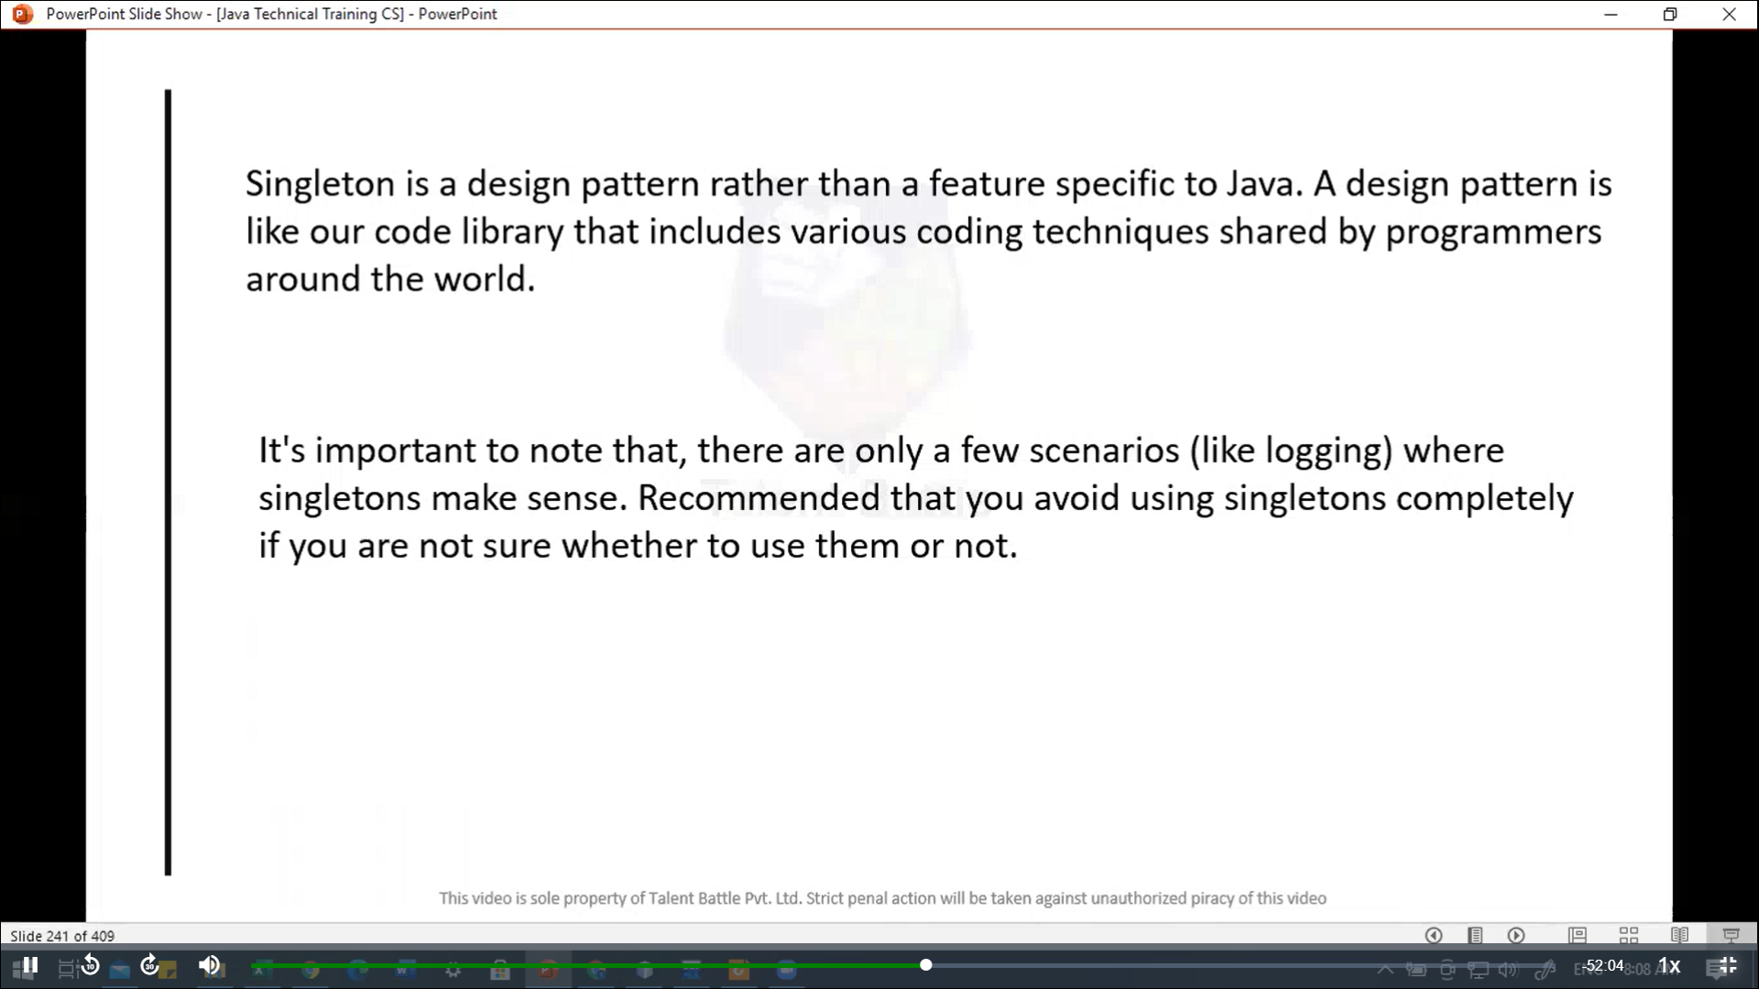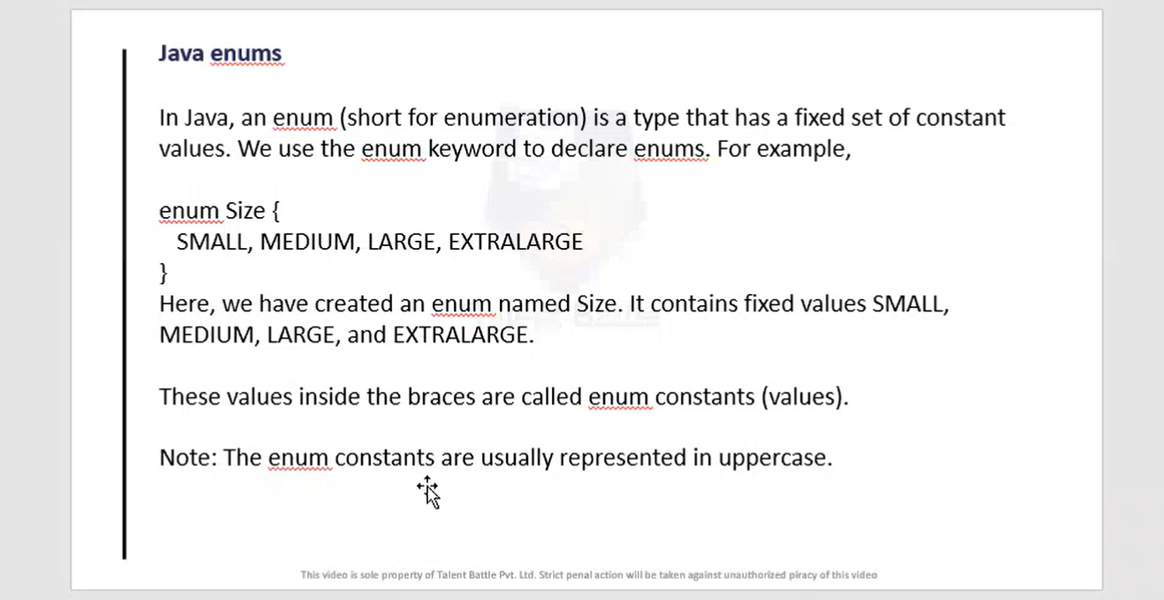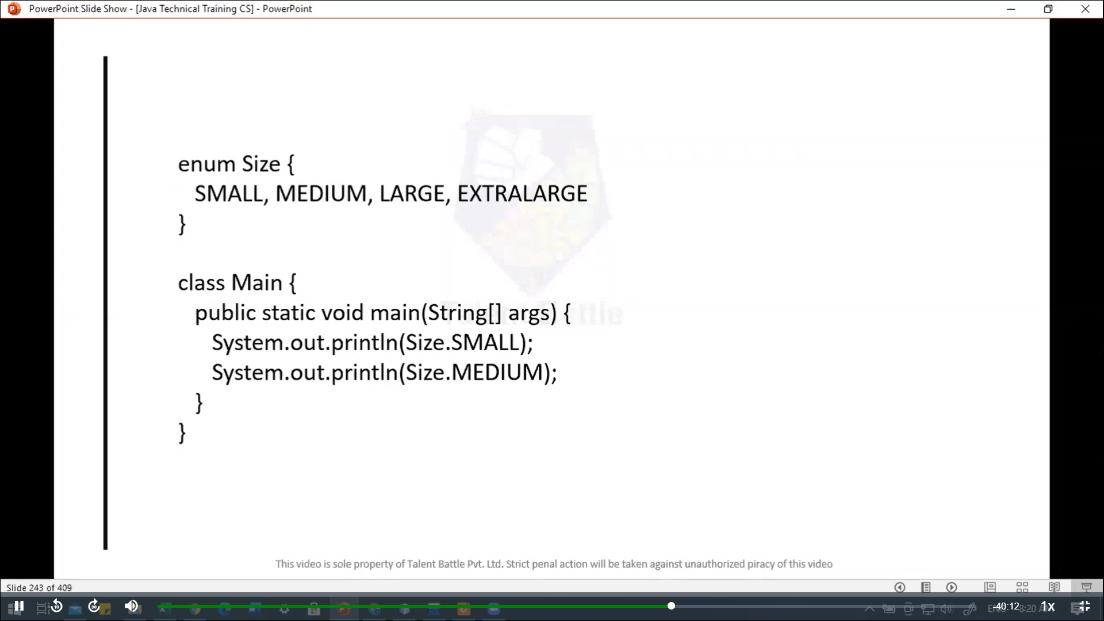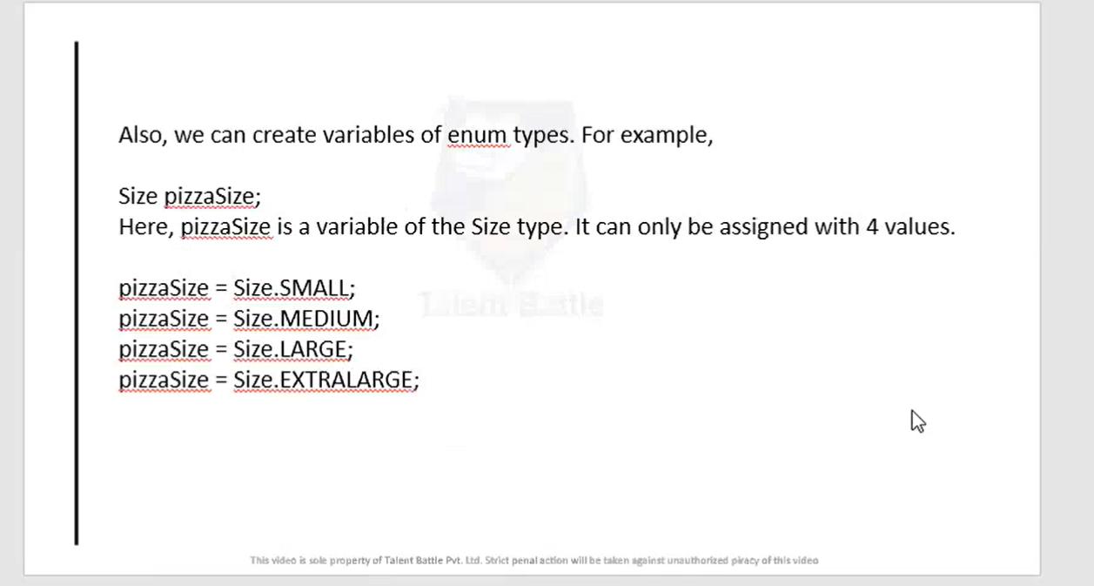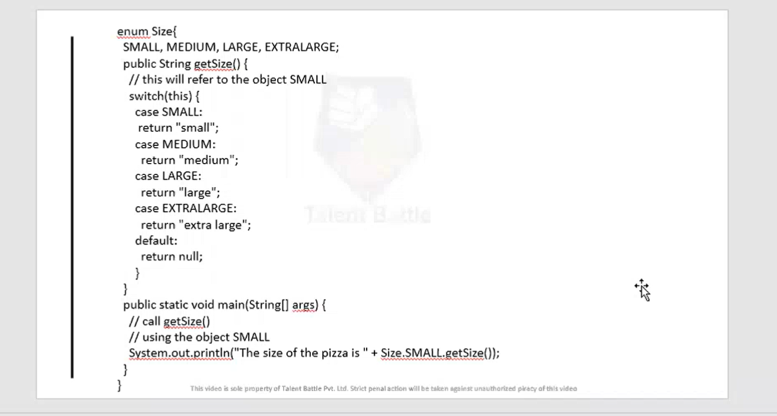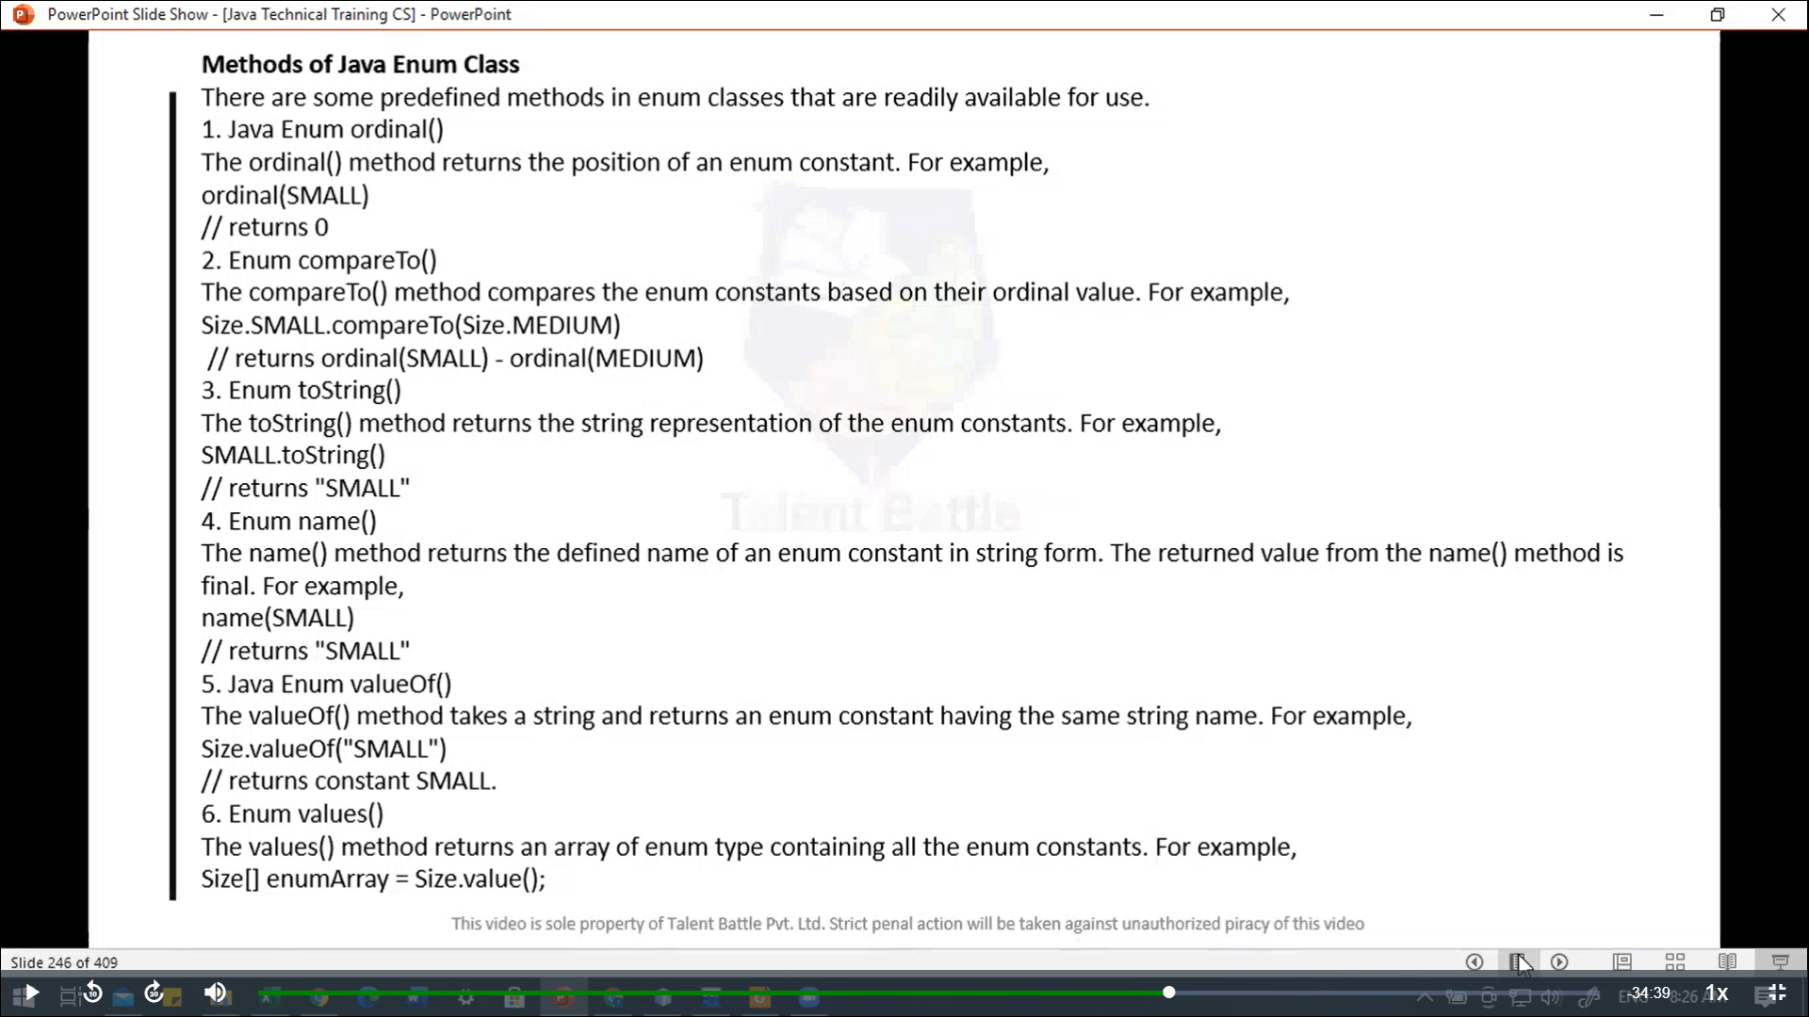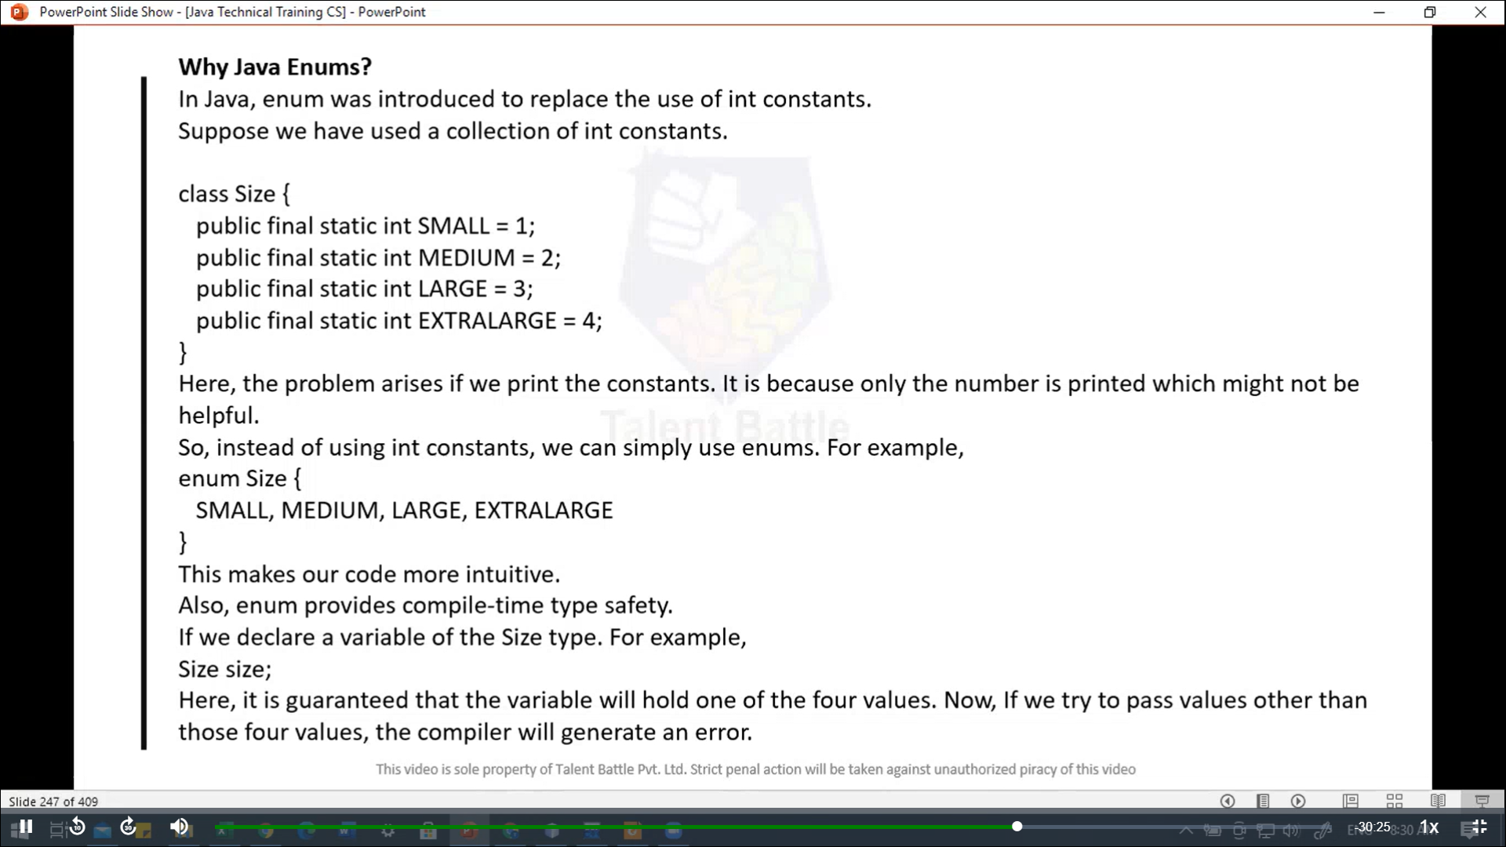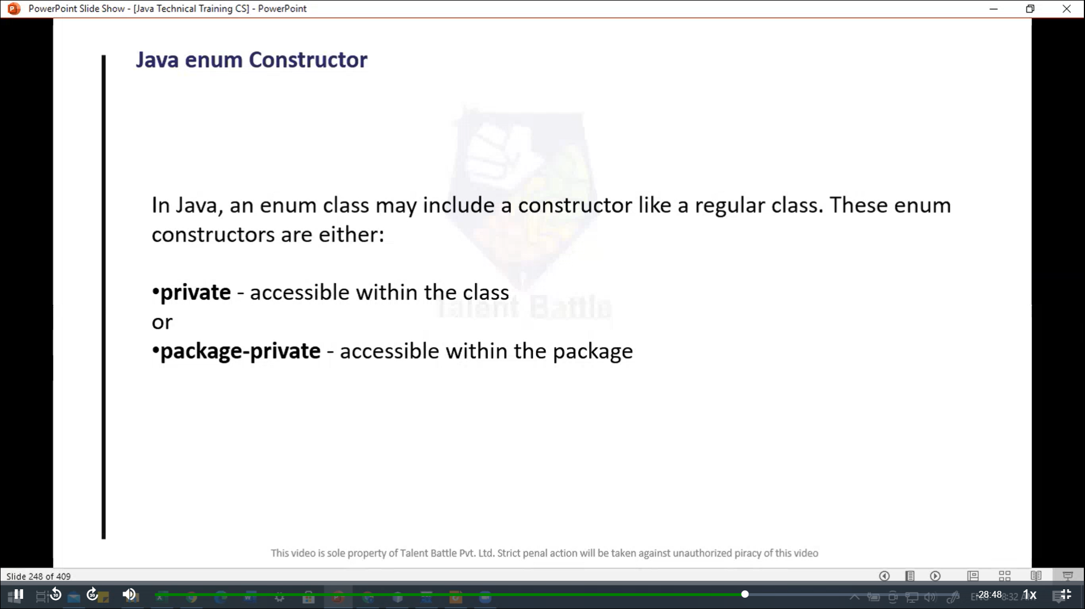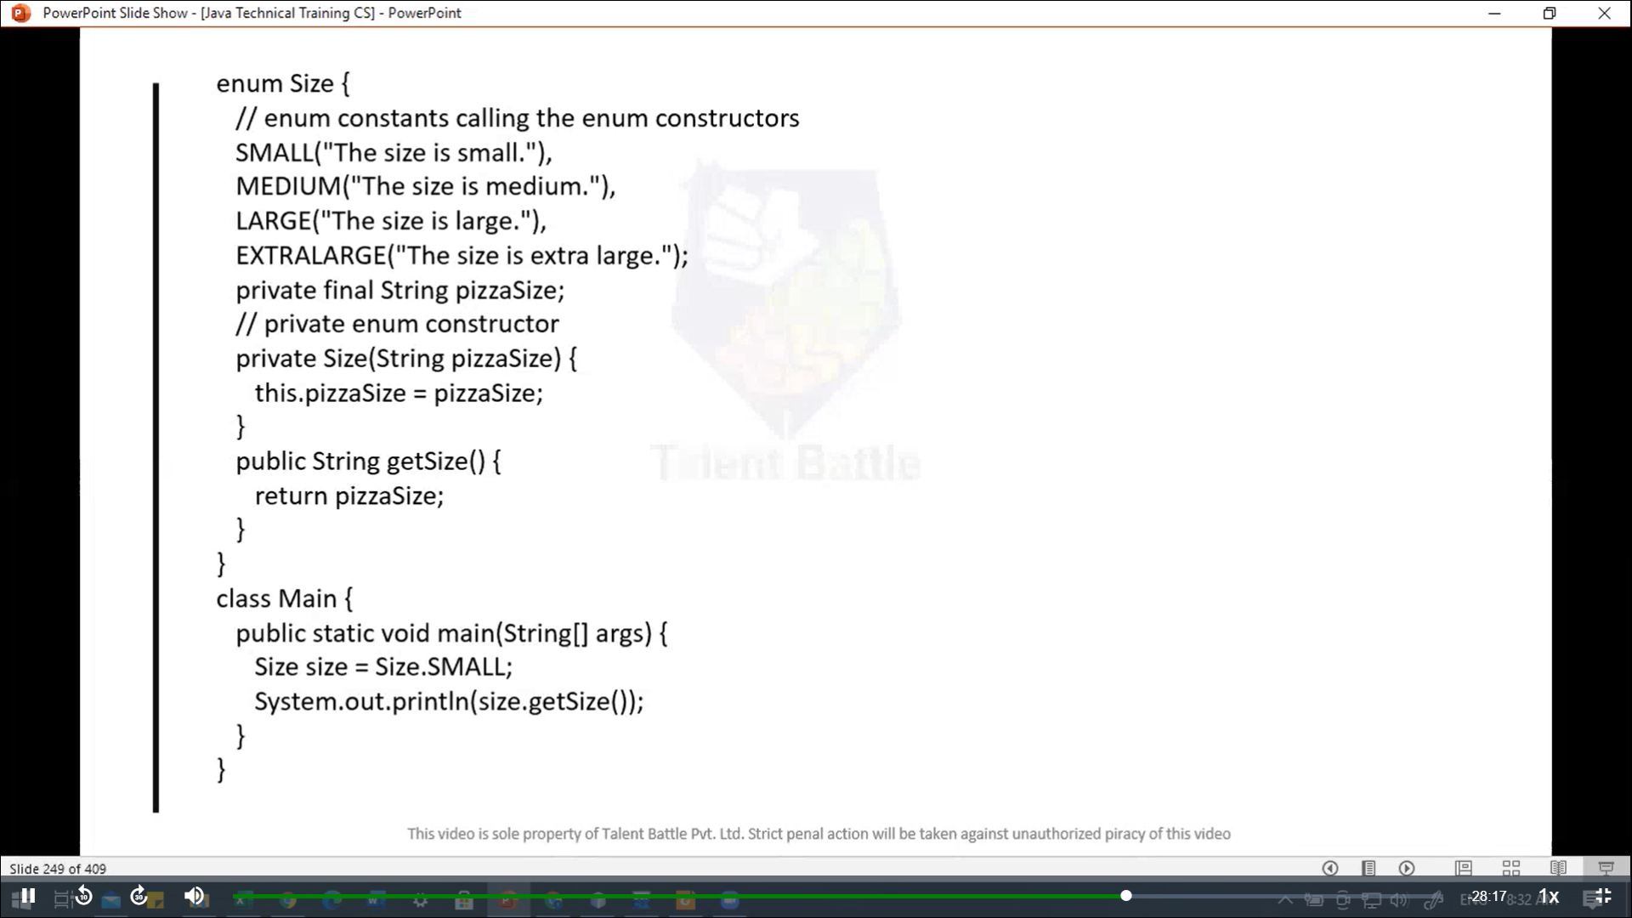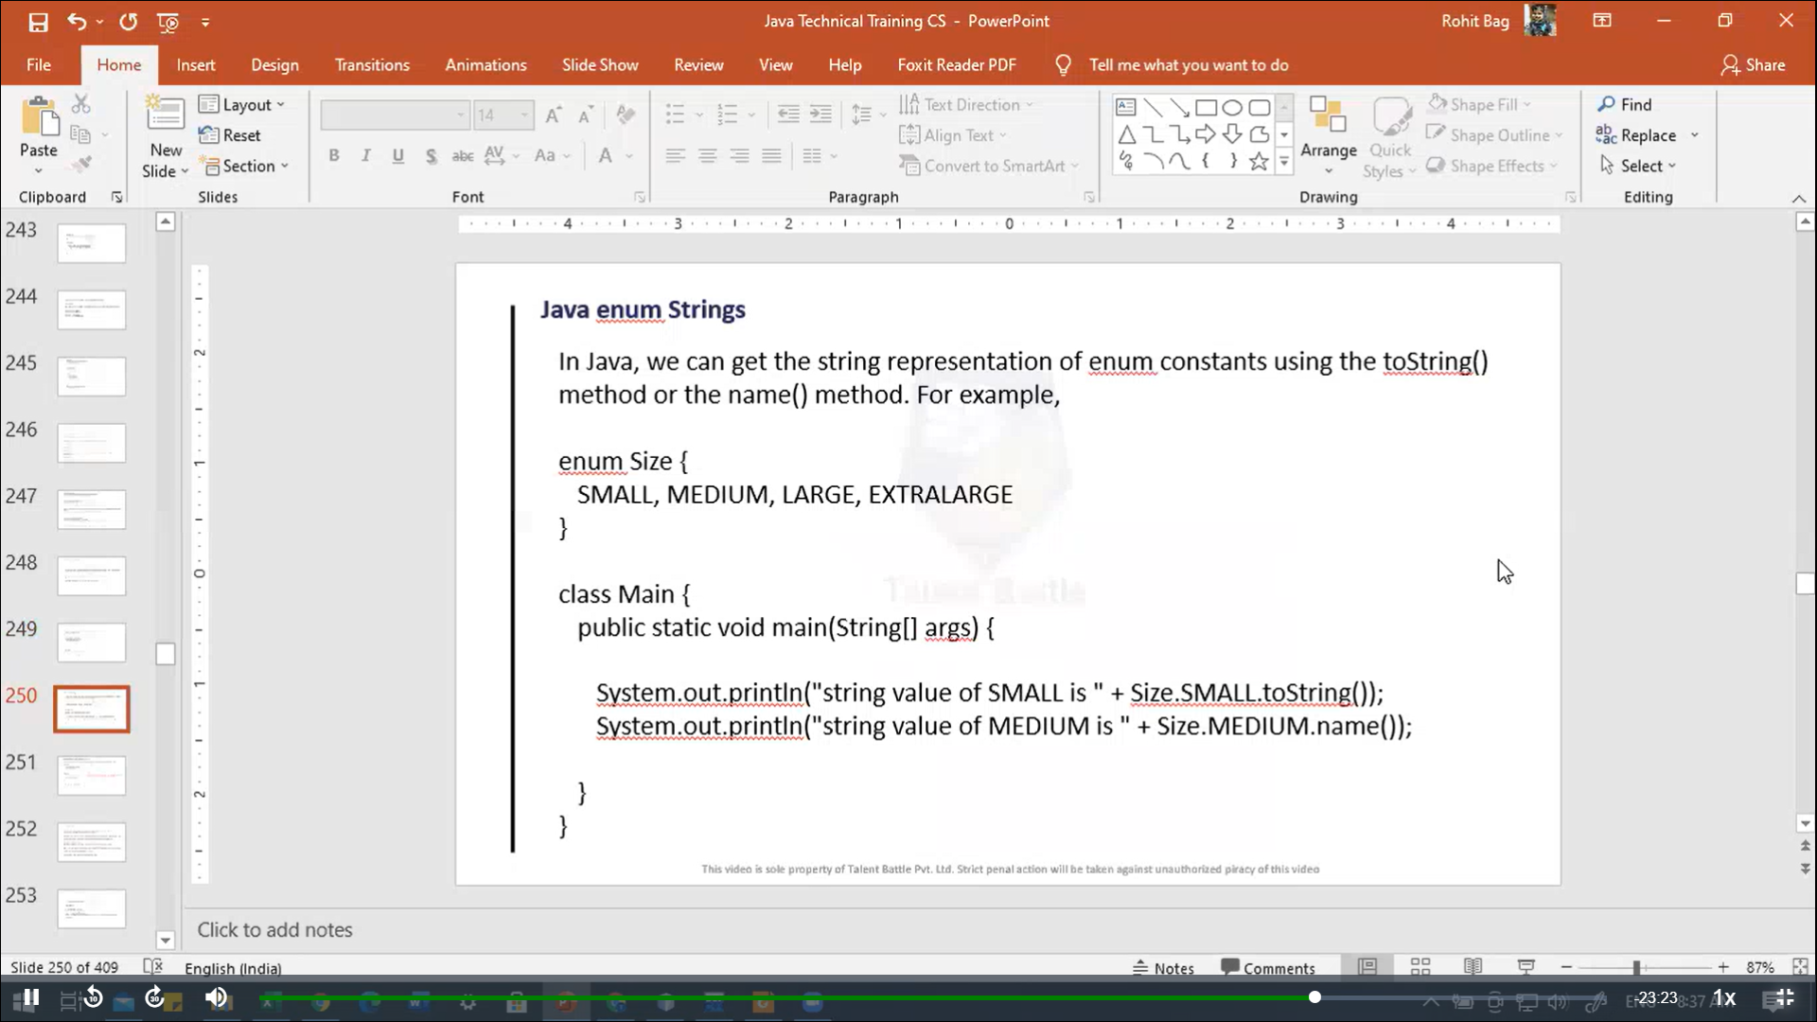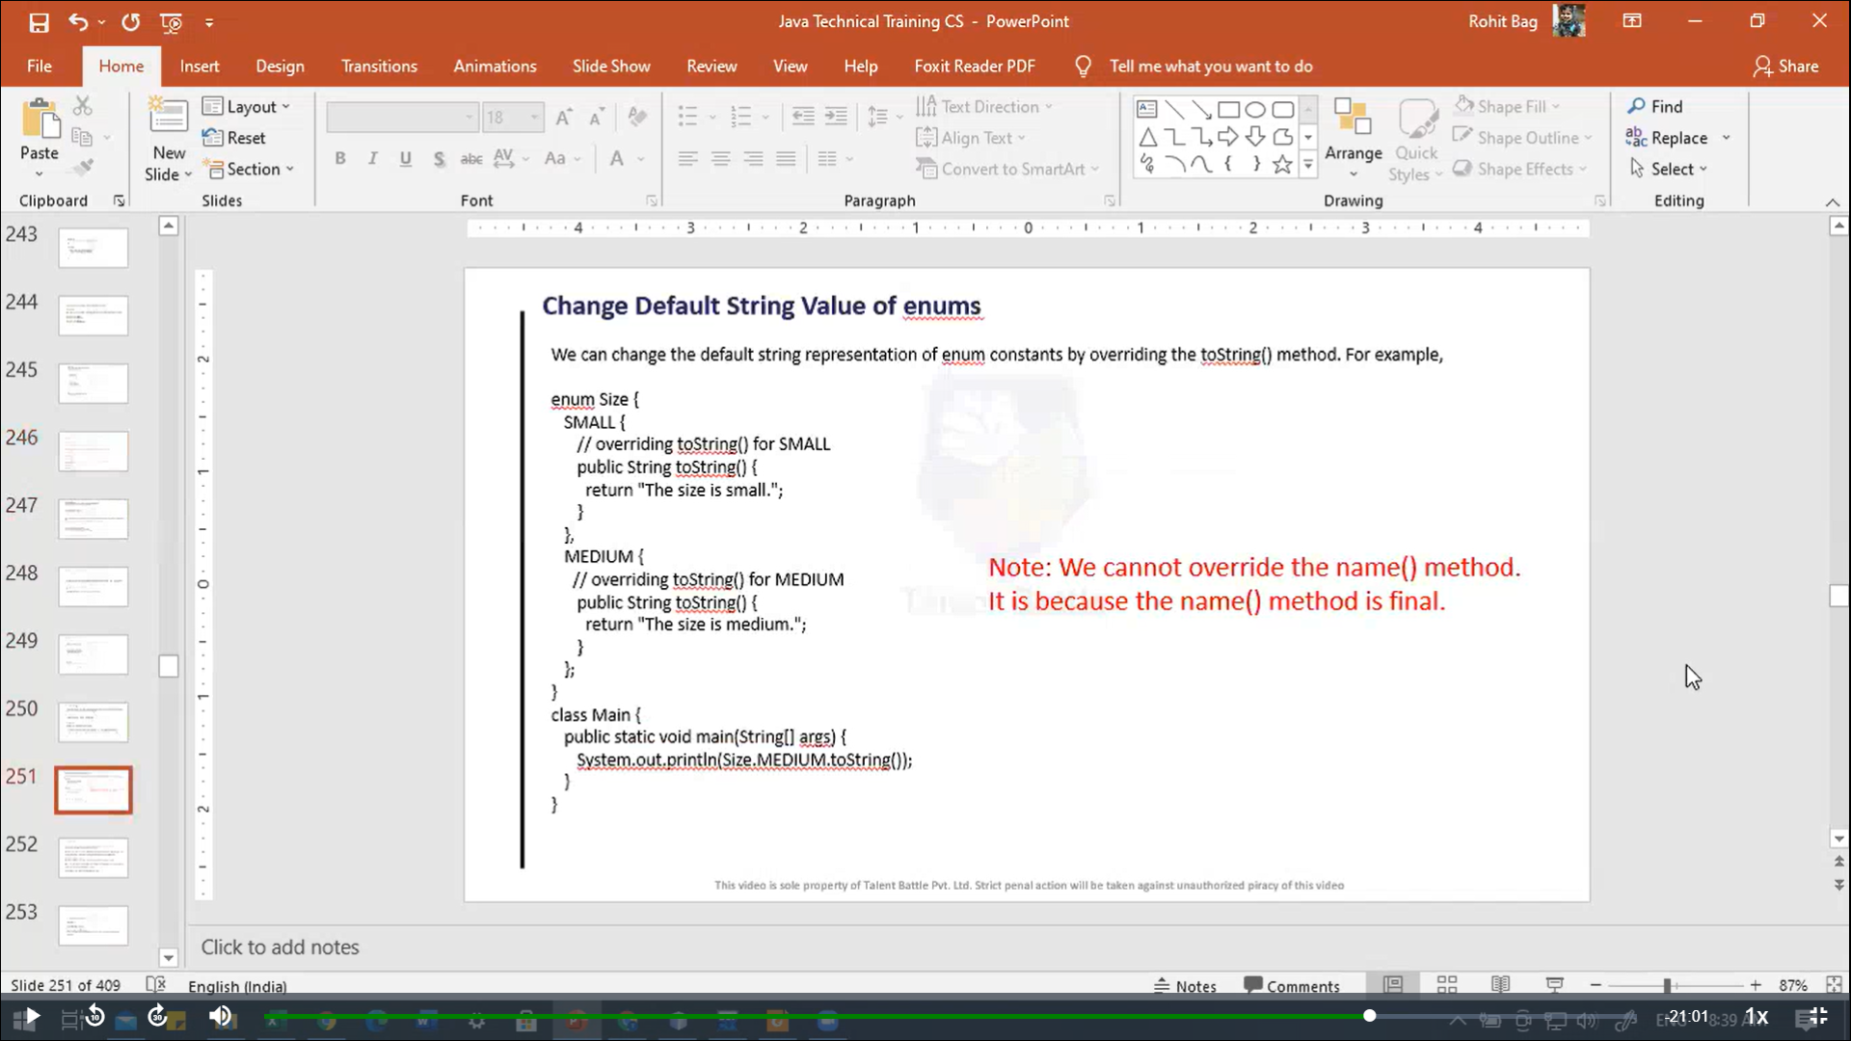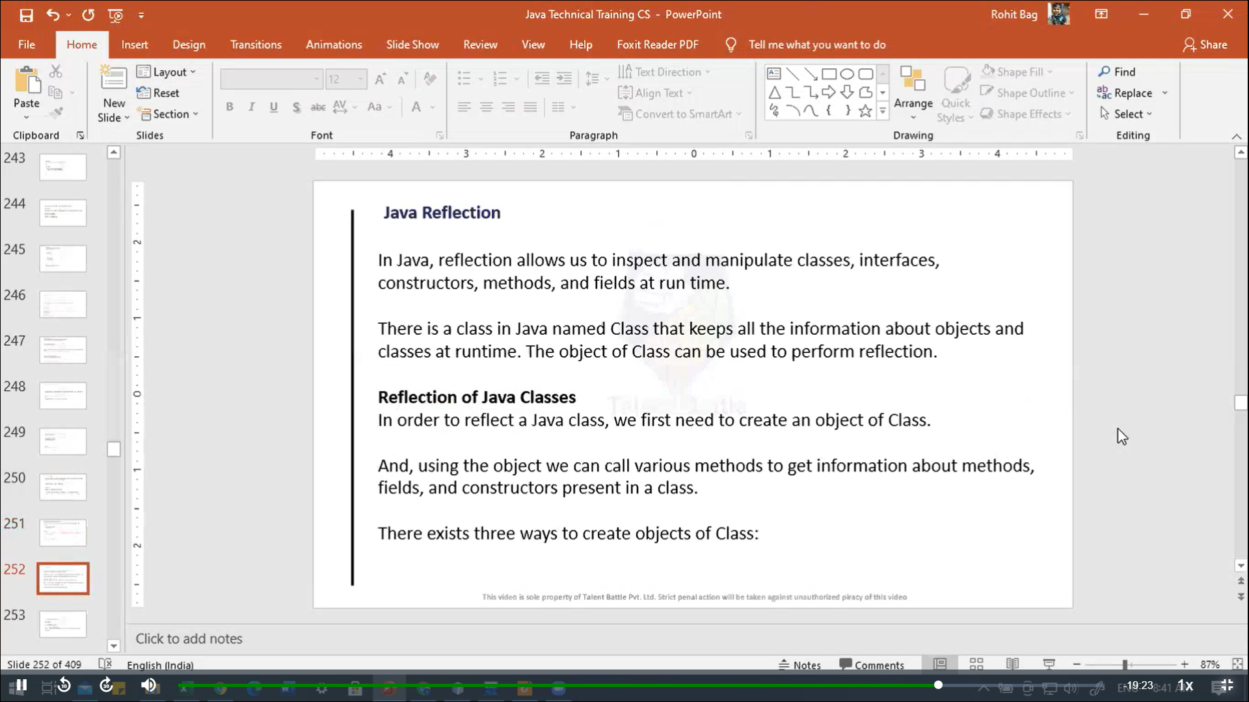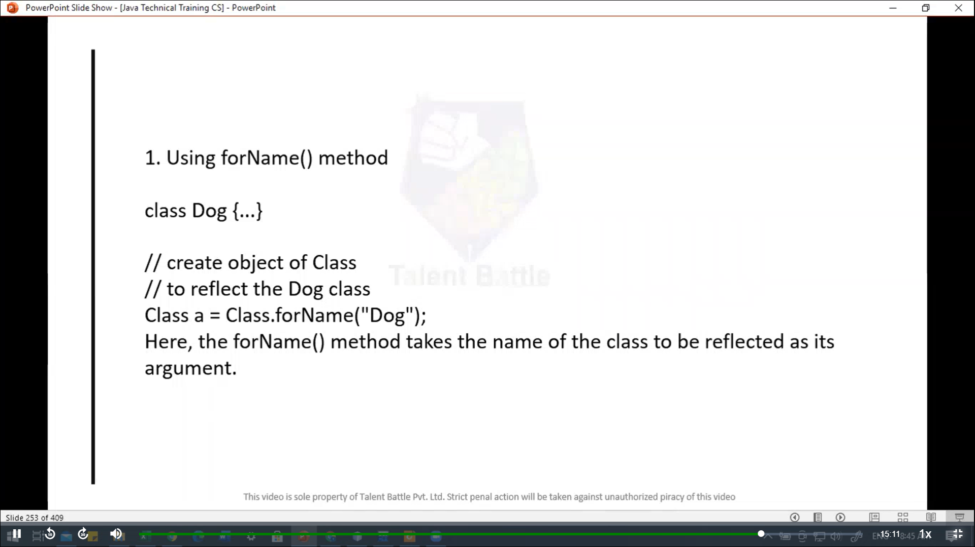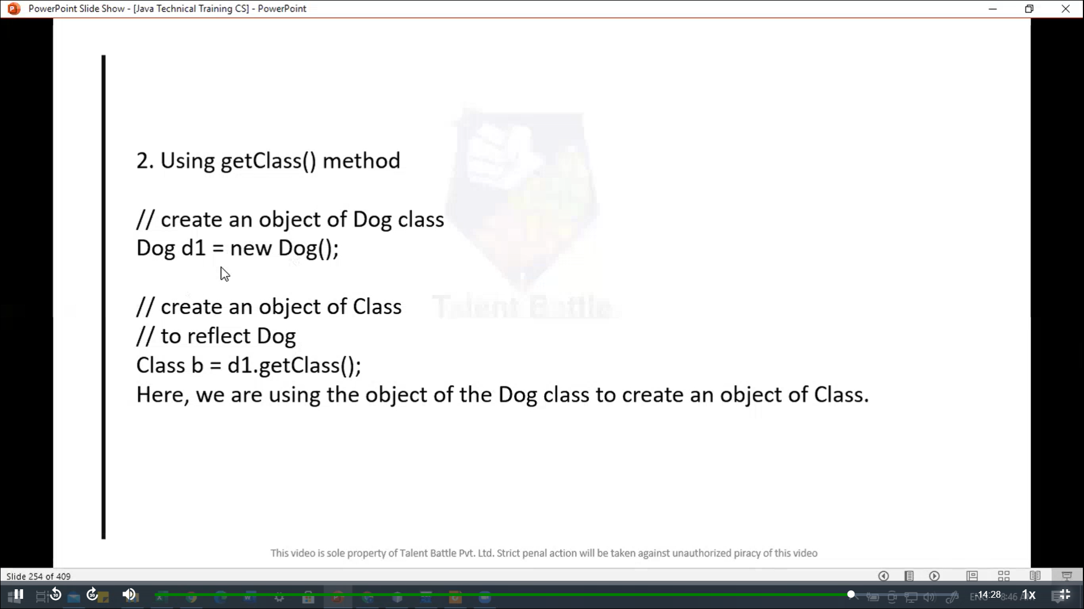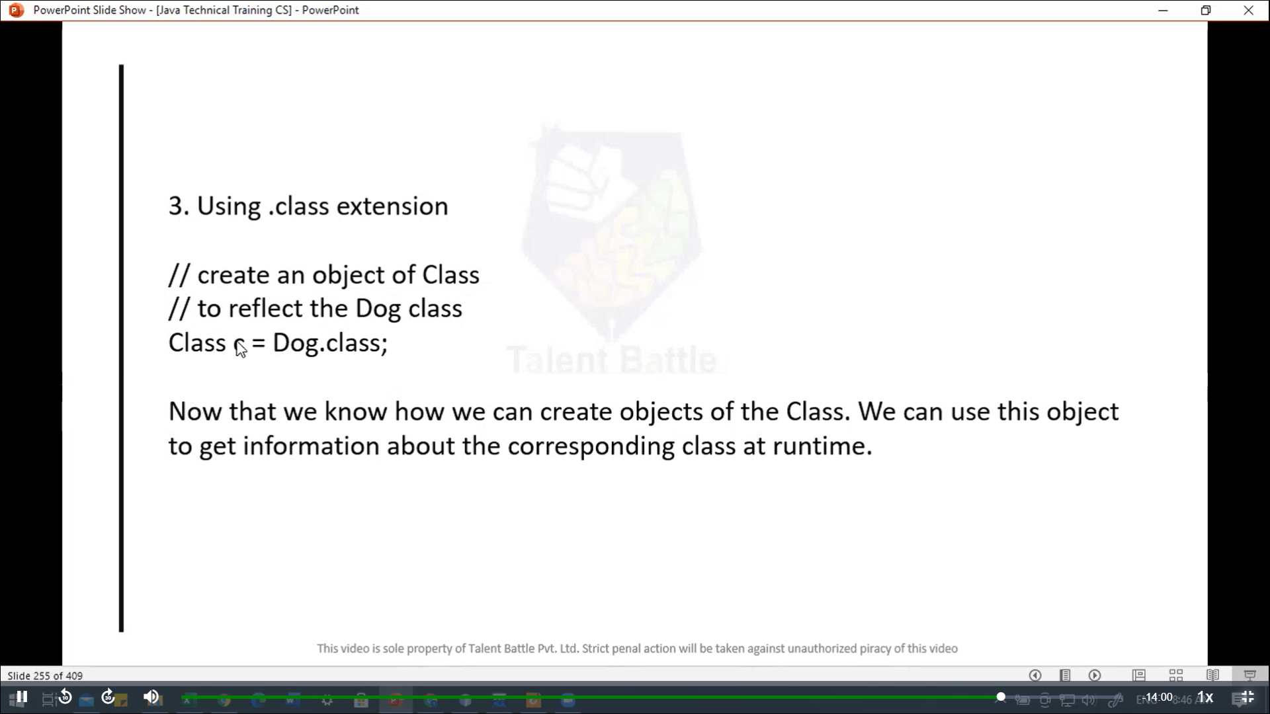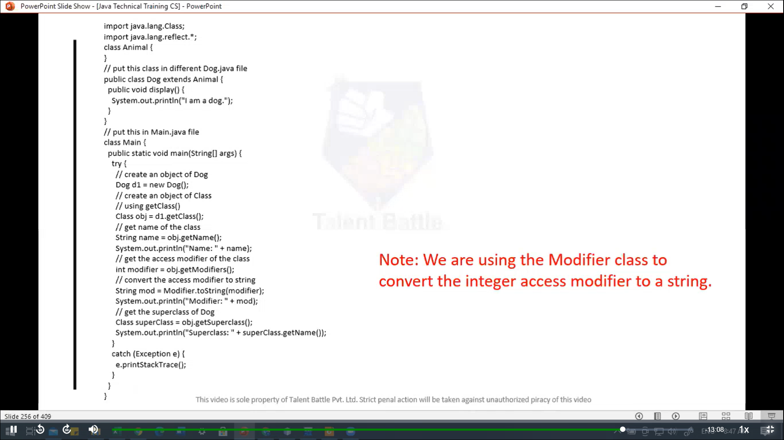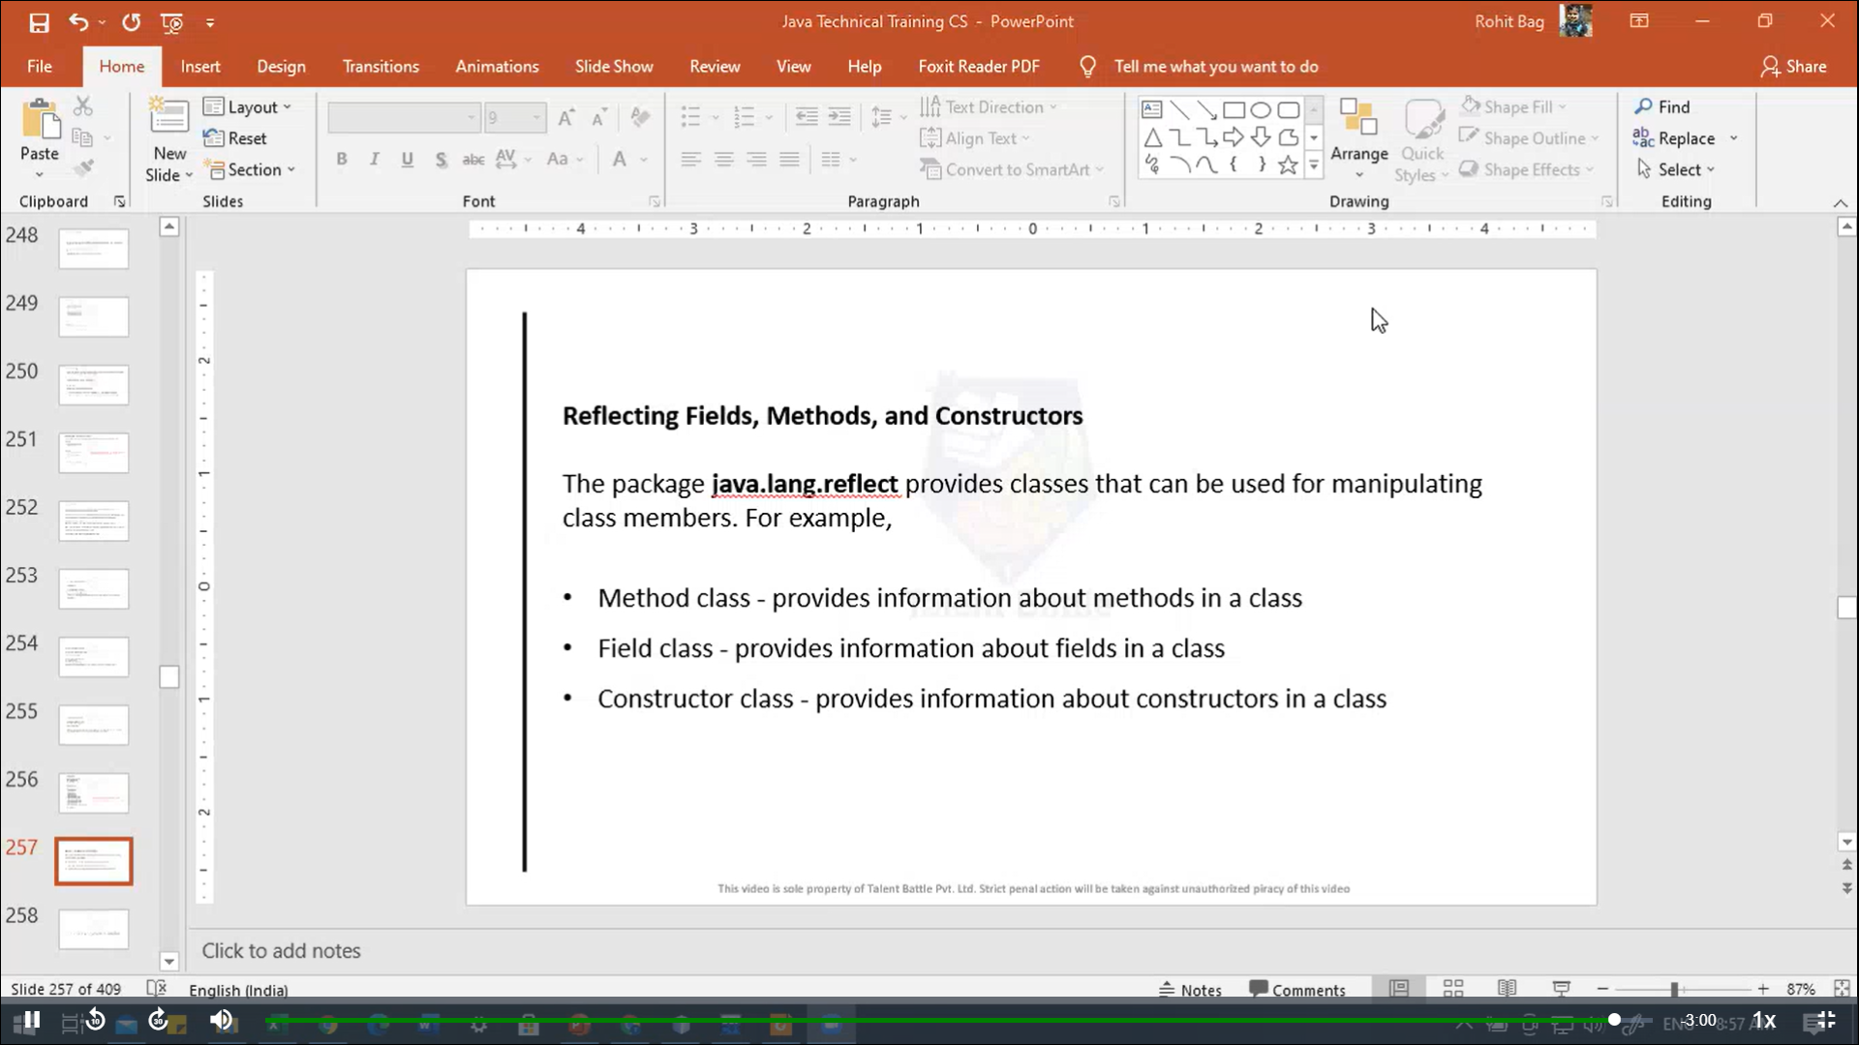

package Day8;

*/\**

*// Example: Polymorphism using method overriding*

*// Note: The method that is called is determined during the execution of the program. Hence, method overriding is a run-time polymorphism*

*class Language{*

*public void displayInfo(){*

*System.out.println("Common English Language");*

*}*

*}*

*class Java extends Language{*

*@Override*

*public void displayInfo(){*

*System.out.println("Java Programming Language");*

*}*

*}*

*public class Main{*

*public static void main(String[] args){*

*// create an object of java class*

*Java j1 = new Java();*

*j1.displayInfo();*

*// create an object of Language class*

*Language l1 = new Language();*

*l1.displayInfo();*

*}*

*}*

*// ++++++++++++++++++ output +++++++++++++++++++++++*

*// vscode ➜ /workspaces/Foundation-Language/Java/Day8 (main) $ javac Main.java*

*// vscode ➜ /workspaces/Foundation-Language/Java/Day8 (main) $ java Main*

*// Java Programming Language*

*// Common English Language*

*\*/*

*//------------------------------------------------------------*

*/\**

*// Polymorphis using method overloading*

*// Note: The method that is called is determined by the compiler. Hence it is also known as compile-time polymorphism*

*class Pattern {*

*// method without parameter*

*public void display(){*

*for(int i = 0; i < 10; i++){*

*System.out.print("*");*

*}*

*}*

*// method with single parameter*

*public void display(char symbol){*

*for(int i = 0; i < 10; i++){*

*System.out.print(symbol);*

*}*

*}*

*}*

*public class Main {*

*public static void main(String[] args){*

*// create an object of Pattern class*

*Pattern d1 = new Pattern();*

*d1.display();*

*System.out.println("\n");*

*d1.display('#');*

*}*

*}*

*// +++++++++++++++++++ output ++++++++++++++++++++++*

*// @Dheeraj2002kumar ➜ /workspaces/Foundation-Language (main) $  /usr/bin/env /usr/lib/jvm/msopenjdk-current/bin/java -XX:+ShowCodeDetailsInExceptionMessages -cp /home/vscode/.vscode-remote/data/User/workspaceStorage/77461b5d-1/redhat.java/jdt_ws/Foundation-Language_c2e17210/bin Day8.Main*

*// \*\*\*\*\*\*\*\*\*\**

*// ##########@Dheeraj2002kumar ➜ /workspaces/Foundation-Language (main) $*

*\*/*

*// ----------------------------------------------*

*/\**

*// encapsulation*

*class Area{*

*// fields to calculate area*

*int length;*

*int breadth;*

*// constructor to initialize values*

*Area(int length, int breadth){*

*this.length = length;*

*this.breadth = breadth;*

*}*

*// method to calculate area*

*public void getArea(){*

*int area = length*breadth;*

*System.out.println("Area: " + area);*

*}*

*}*

*public class Main{*

*public static void main(String[] args){*

*// create object of Area*

*// pass value of length and breadth*

*Area rectangle = new Area(5, 6);*

*rectangle.getArea();*

*}*

*}*

*// +++++++++++++++++++ output +++++++++++++++++++++++++++*

*// @Dheeraj2002kumar ➜ /workspaces/Foundation-Language/Java (main) $ java Day8.Main*

*// Area: 30*

*\*/*

*// ---------------------------------------------------------------*

*/\**

*// Data Hiding:-*

*// Data hiding is a way of restricting the access of our data members by hiding the implementation details.*

*class Person{*

*// private field*

*private int age;*

*// getter method*

*public int getAge(){*

*return age;*

*}*

*// setter method*

*public void setAge(int age){*

*this.age = age;*

*}*

*}*

*public class Main{*

*public static void main(String[] args){*

*// create an object of Person*

*Person p1 = new Person();*

*// change age using setter*

*p1.setAge(24);*

*// access age using getter*

*System.out.println("My age is " + p1.getAge());*

*}*

*}*

*// +++++++++++++++++++++++++++ output ++++++++++++++++++++++++++++*

*// @Dheeraj2002kumar ➜ /workspaces/Foundation-Language/Java (main) $ java Day8.Main*

*// My age is 24*

*\*/*

*// ----------------------------------------------*

*// none-static nested class*

*// Note: we use the dot(.) operator to create an instance of the inner class using the outer class*

*/\**

*class CPU{*

*double price;*

*// nested class*

*class Processor{*

*// members of nested class*

*double core;*

*String manufacturer;*

*double getCache(){*

*return 4.3;*

*}*

*}*

*// nested protected clas*

*protected class RAM{*

*// member of protected nested class*

*double memory;*

*String manufacturer;*

*double getClockSpeed(){*

*return 5.5;*

*}*

*}*

*}*

*public class Main{*

*public static void main(String[] args) {*

*// create object of Outer class CPU*

*CPU cpu = new CPU();*

*// create an objecte of inner class Processor using class*

*CPU.Processor processor = cpu.new Processor();*

*// create an object of inner class RAM using outer class CPU*

*CPU.RAM ram = cpu.new RAM();*

*System.out.println("Processar Cache = " + processor.getCache());*

*System.out.println("Ram Clock speed = " + ram.getClockSpeed());*

*}*

*}*

*\*/*

*// ++++++++++++++++++ output ++++++++++++++++++++++++++*

*//  @Dheeraj2002kumar ➜ /workspaces/Foundation-Language/Java (main) $ java Day8.Main*

*// Processar Cache = 4.3*

*// Ram Clock speed = 5.5*

*//-----------------------------------------------------*

*// Java nested static class*

*/\**

*class Animal {*

*// inner class*

*class Reptile {*

*public void displayInfo(){*

*System.out.println("I am a reptile...");*

*}*

*}*

*// static class*

*static class Mammal{*

*public void displayInfo(){*

*System.out.println("I am a mammal...");*

*}*

*}*

*}*

*class Main{*

*public static void main(String[] args) {*

*// object creation of the outer class*

*Animal animal = new Animal();*

*// object creation of the non-static class*

*Animal.Reptile reptile = animal.new Reptile();*

*reptile.displayInfo();*

*// object creation of the static nested class*

*Animal.Mammal mammal = new Animal.Mammal();*

*mammal.displayInfo();*

*}*

*}*

*\*/*

*// ++++++++++++++ output +++++++++++++++++++++++++++++++*

*// @Dheeraj2002kumar ➜ /workspaces/Foundation-Language/Java (main) $ javac Day8/Main.java*

*// @Dheeraj2002kumar ➜ /workspaces/Foundation-Language/Java (main) $ java Day8.Main*

*// I am a reptile...*

*// I am a mammal...*

*// ----------------------------------------------------------*

*// Java Anonymous Class*

*/\**

*class Polygon {*

*public void display(){*

*System.out.println("Inside the Polygon class");*

*}*

*}*

*class AnonymousDemo {*

*public void createClass(){*

*// creation of anonymous class extending class Polygon*

*Polygon p1 = new Polygon(){*

*public void display(){*

*System.out.println("Inside an anonymous class.");*

*}*

*};*

*p1.display();*

*}*

*}*

*class Main{*

*public static void main(String[] args){*

*AnonymousDemo an = new AnonymousDemo();*

*an.createClass();*

*// Polygon p1 = new Polygon();*

*// p1.display();*

*}*

*}*

*\*/*

*// ++++++++++++++++++++ output ++++++++++++++++++++++*

*// @Dheeraj2002kumar ➜ /workspaces/Foundation-Language/Java (main) $ javac Day8/Main.java*

*// @Dheeraj2002kumar ➜ /workspaces/Foundation-Language/Java (main) $ java Day8.Main*

*// Inside an anonymous class.*

*//-----------------------------------------------------------------*

*// Java Singleton*

*/\**

*class Database {*

*private static Database dbObject;*

*private Database(){*

*}*

*public static Database getInstance(){*

*// create objet if it's not already created*

*if(dbObject == null){*

*dbObject = new Database();*

*}*

*// return the singleton object*

*return dbObject;*

*}*

*public void getConnection(){*

*System.out.println("You are now connected to the database...");*

*}*

*}*

*public class Main{*

*public static void main(String[] args){*

*Database db1;*

*// refers to the only object of Database*

*db1 = Database.getInstance();*

*db1.getConnection();*

*}*

*}*

*\*/*

*//+++++++++++++++++++ output +++++++++++++++++++++++++*

*// @Dheeraj2002kumar ➜ /workspaces/Foundation-Language/Java (main) $ javac Day8/Main.java*

*// @Dheeraj2002kumar ➜ /workspaces/Foundation-Language/Java (main) $ java Day8.Main*

*// You are now connected to the database...*

*//----------------------------------------------------*

*// Java enum*

*/\**

*enum Size {*

*SMALL, MEDIUM, LARGE, EXTRALARGE*

*}*

*class Main{*

*public static void main(String[] args){*

*System.out.println(Size.SMALL);*

*System.out.println(Size.MEDIUM);*

*}*

*}*

*\*/*

*// ++++++++++++++++++++ output ++++++++++++++++++*

*// @Dheeraj2002kumar ➜ /workspaces/Foundation-Language/Java (main) $ javac Day8/Main.java*

*// @Dheeraj2002kumar ➜ /workspaces/Foundation-Language/Java (main) $ java Day8.Main*

*// SMALL*

*// MEDIUM*

*//----------------------------------------------------------*

*// java enum*

*/\**

*enum Size{*

*SMALL, MEDIUM, LARGE, EXTRALARGE;*

*public String getSize(){*

*// this will refer to the object SMALL*

*switch(this){*

*case SMALL:*

*return "small";*

*case MEDIUM:*

*return "medium";*

*case LARGE:*

*return "large";*

*case EXTRALARGE:*

*return "extra large";*

*default:*

*return null;*

*}*

*}*

*}*

*public class Main{*

*public static void main(String[] args){*

*// call getSize()*

*// using the object SMALL*

*System.out.println("The size of the pizza is " + Size.SMALL.getSize());*

*}*

*}*

*\*/*

*// ++++++++++++++++ output +++++++++++++++++++++++++++++*

*// @Dheeraj2002kumar ➜ /workspaces/Foundation-Language/Java (main) $ javac Day8/Main.java*

*// @Dheeraj2002kumar ➜ /workspaces/Foundation-Language/Java (main) $ java Day8.Main*

*// The size of the pizza is small*

*//------------------------------------------------------------*

*// java enum constructors*

*/\**

*enum Size {*

*// Enum constants calling the enum constructors*

*SMALL("The size is small..."),*

*MEDIUM("The size is medium..."),*

*LARGE("The size is large..."),*

*EXTRALARGE("The size is extra large...");*

*// Private enum constructor*

*private String pizzaSize;*

*private Size(String pizzaSize) {*

*this.pizzaSize = pizzaSize;*

*}*

*public String getSize() {*

*return pizzaSize;*

*}*

*}*

*public class Main {*

*public static void main(String[] args) {*

*Size size = Size.SMALL;*

*System.out.println(size.getSize());*

*}*

*}*

*\*/*

*// ++++++++++++++++++++++++ output +++++++++++++++++++++++++++++*

*// @Dheeraj2002kumar ➜ /workspaces/Foundation-Language/Java (main) $ javac Day8/Main.java*

*// @Dheeraj2002kumar ➜ /workspaces/Foundation-Language/Java (main) $ java Day8.Main*

*// The size is small...*

*// --------------------------------------------------------*

*// java enum Strings*

*// In java, we can get the string representation of an enum constant using the toString() method or the name() method.*

*/\**

*enum Size{*

*SMALL, MEDIUM, LARGE, EXTRALARGE;*

*}*

*class Main{*

*public static void main(String[] args){*

*System.out.println("String value of SMALL is :" + Size.SMALL.toString());*

*System.out.println("String value of Medium is :" + Size.MEDIUM.name());*

*}*

*}*

*\*/*

*// ++++++++++++++++++++++++ output +++++++++++++++++++++++++++++*

*// @Dheeraj2002kumar ➜ /workspaces/Foundation-Language/Java (main) $ javac Day8/Main.java*

*// @Dheeraj2002kumar ➜ /workspaces/Foundation-Language/Java (main) $ java Day8.Main*

*// String value of SMALL is :SMALL*

*// String value of Medium is :MEDIUM*

*// -----------------------------------------------------*

*// change Default String value of enums*

*// We can change the default string representation of enum constants by overriding the toString() method.*

*// Note: We cannot override the name() method. It is because the name() method is final.*

*/\**

*enum Size{*

*SMALL{*

*// override toString for SMALL*

*public String toString(){*

*return "The size is small.";*

*}*

*},*

*MEDIUM {*

*// override toString() for MEDIUM*

*public String toString(){*

*return "The size is medium...";*

*}*

*};*

*}*

*class Main{*

*public static void main(String[] args){*

*System.out.println(Size.MEDIUM.toString());*

*}*

*}*

*\*/*

*//  ++++++++++++++++++++++++ output +++++++++++++++++++++++++++++*

*// @Dheeraj2002kumar ➜ /workspaces/Foundation-Language/Java (main) $ javac Day8/Main.java*

*// @Dheeraj2002kumar ➜ /workspaces/Foundation-Language/Java (main) $ java Day8.Main*

*// The size is medium...*